**FOR IMMEDIATE RELEASE**

**October 2022**

**Publicity Team**

804-644-3090  
pr@brandylanepublishers.com

***My Teddy Knight in Shining Armor* Shows Kids How to Conquer Their Fears—with Just a Few Deep Breaths!**

written by Bridgette Fowler

illustrated by Alejandro Echavez

on sale November 16, 2022

“Kids of all ages will love this heartwarming bedtime story. The illustrations are wonderful—You’ll find yourself studying the details on every page.”

- Tonya Calvert, author of *Saylor on the Seashore* and *The Origami Elephant*

[Belle Isle Books](http://www.belleislebooks.com/) of Richmond, Virginia, is pleased to announce the upcoming release of a new children’s book, *My Teddy Knight in Shining Armor*, written by Bridgette Fowler and illustrated by Alejandro Echavez.

Bedtime can be unwelcome when scary dreams beckon—but luckily, this book’s child protagonist has a teddy bear in shining armor to help him face his fears! When the young dreamer finds himself in a cold, fearsome castle populated by big, frightening bugs, his teddy knight is there to help lead him to a beautiful, welcoming garden—and to show him that things aren’t always as scary as they seem.

Filled with vibrant, cartoonish illustrations that bring the text to brilliant life while encouraging the sweetest of dreams, *My Teddy Knight in Shining Armor* is scheduled for release on November 16, 2022.

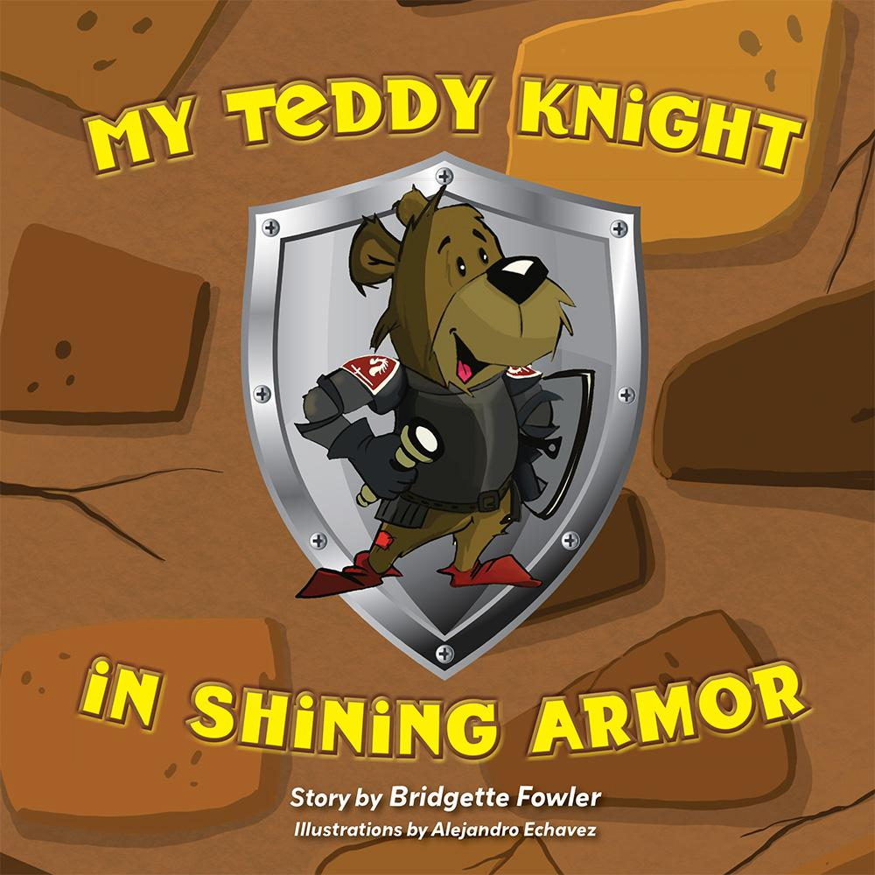

Teddy wasn’t afraid. He said, “Breathe.”

One deep breath—two deep breaths—three deep breaths.

*Join two best friends on a most unexpected adventure as they explore the five senses and learn to manage fear along the way!*

**About the Author**

Bridgette Fowler was born into a family of educators, and embraced the notion that to read is to learn at an early age. As an author, she expanded her belief to include that to write is to facilitate a learning opportunity—with the caveat that learning opportunities are often better digested when disguised in colorful and engaging costumes.

Imaginative learning opportunities, kindness, and attention to inner calmness are at the heart of Bridgette’s writing. A proponent and practitioner of mindfulness who is ever amazed at the extraordinary benefits of a single slow, deep breath, she imparts this wisdom through her children’s books, *Grow with Me Poetry* and *My Teddy Knight in Shining Armor.* “Read to imagine, then write,” she is fond of saying, “—and above all, know that every word matters.”

A retired audiologist, Bridgette will forever hold a special place in her heart for the little children with whom she worked over the three decades of her career—and as the mother of two adult children, she also retains fond memories of the little children they once were.

**About the Illustrator**

Alejandro Echavez is a freelance illustrator, painter, and storyboard artist specializing in children’s books. He currently resides in Long Island, NY, but spent his formative years in Bogota, Colombia, where he first showed a fascination for art at age six. More than an interest, it was a natural talent that his family nurtured and developed. As he’s a kid at heart, his artwork is often playful, and makes use of bright colors to create movement and vibrancy.

Alejandro has illustrated more than thirty books written by various authors from all over the United States, and has also contributed to the creation of gaming apps. He is currently working on three children books and a mural at the Shedd Aquarium in Chicago, and hopes to continue creating the vibrant artwork he is known for.

You can find more of Alejandro’s work at www.alejoartworks.com, on Instagram @_alejoartworks, or on Facebook at http://www.facebook.com/alejoartworks.

**Interviews available upon request.**

[Belle Isle Books](http://www.belleislebooks.com/), an imprint of [Brandylane Publishers, Inc.](https://brandylanepublishers.com/), is an independent press located in Richmond, Virginia that has published books since 1985.

___________

*My Teddy Knight in Shining Armor* (hardcover, 36 pages, $25.95 / paperback, 36 pages, $15.95 / Kindle e-book, $2.99) is available for pre-order from [Amazon](https://www.amazon.com/Losing-Tooth-Nicole-Wright/dp/1953021913), [Barnes & Noble](https://www.barnesandnoble.com/w/losing-a-tooth-nicole-wright/1141758083?ean=9781953021915), and other fine booksellers.