**FOR IMMEDIATE RELEASE**

**April 2023**

**Publicity Team**

804-644-3090  
pr@brandylanepublishers.com

**Contemplate the World in Myriad Ways through the Eyes of a Teenage Poet in *Myriad of a Soul***

written by Sydney Gallagher

on sale May 18, 2023

“…a deeply personal and vulnerable experience that will stir the reader with emotion. Prepare to feel everything.”

- Douglas Powell/Roscoe Burnems, first poet laureate for Richmond, Virginia

[Belle Isle Books](http://www.belleislebooks.com/) of Richmond, Virginia, is pleased to announce the upcoming release of a new poetry collection, [*Myriad of a Soul*](http://www.belleislebooks.com/store/p223/Myriad_of_a_Soul.html) by Sydney Gallagher.

As social media and the issues it presents turn a lens on the increasing complexity of today’s world, navigating that world can feel equally complex, and even hopeless—especially for the youth. *Myriad of a Soul* showcases this struggle through the alternately poignantly melancholic and staunchly defiant poetry of a teenager whose desire to explore what she might become conflicts with her desire to please the anxiogenic and often contradictory society in which she finds herself. Longing simultaneously to remain hidden and be seen, and feeling at once lonely and crowded, she grapples with the stifling constraints of modern society—but in the comforting quietude of the nights, she nevertheless finds the inner strength to follow her dreams and take joy in the beauty that surrounds her.

A raw account of impressions from an up-and-coming young poet, *Myriad of a Soul* is scheduled for release on May 18, 2023.

[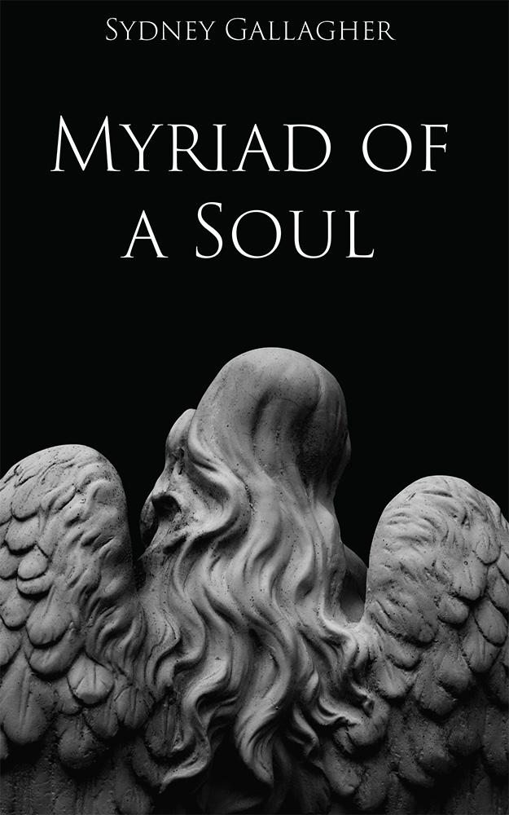](http://www.belleislebooks.com/store/p223/Myriad_of_a_Soul.html)

Myriad of a Soul *is an insightful look into the mind of poet Sydney Gallagher during 2020 and 2021. Thought-provoking and meditative as well as lighthearted, the poems tell the story of a teen who is struggling to understand herself and her place in a rapidly changing society.*

*Written from the perspective of a young woman who understands the value of a self-examined life, this collection will inspire other teens to explore their own identity.*

**About the Author**

[Sydney Gallagher](http://www.belleislebooks.com/sydneygallagher.html) is a high school student in Telluride, Colorado. She is the fourth of five children, values family above all else, and is a lazy perfectionist when it comes to her schoolwork. When she was eight years old, she lost her sister Cameron due to sudden cardiac arrest at the 2014 Shamrock Half Marathon. Now she advocates for teen mental health through her family’s foundation, the Cameron K. Gallagher Foundation. Sydney has a morbid obsession with true crime, fantasy novels, and romance novels, all of which keep her awake well past midnight.

**Interviews available upon request.**

[Belle Isle Books](http://www.belleislebooks.com/), an imprint of [Brandylane Publishers, Inc.](https://brandylanepublishers.com/), is an independent press located in Richmond, Virginia that has published books since 1985.

___________

*Myriad of a Soul* (paperback, 88 pages, $13.95) is available for pre-order from [Amazon](https://www.amazon.com/Myriad-Soul-Sydney-Gallagher/dp/1958754447), [Barnes & Noble](https://www.barnesandnoble.com/w/myriad-of-a-soul-sydney-gallagher/1143221441?ean=9781958754443), and other fine booksellers.