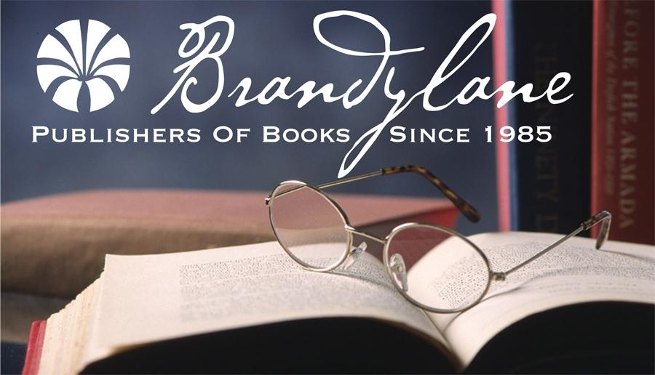

BELLE ISLE BOOKS

*an imprint of Brandylane Publishers, Inc.*

**DATE:   December 2016**

**NEWS**(Release Immediately)

**CONTACT:**For more information, contact Nikki Clemons,[brandylanepr@gmail.com](mailto:brandylanepr@gmail.com), **a**ssistant publicist, orRobert H. Pruett, publisher, at [brandylanerhpruett@gmail.com](mailto:brandylanerhpruett@gmail.com), 804.644.3090; FAX 804.644.3092.

**Nick, the No Good, Icky Tick!**

*New picture book introduces children to ticks*

*and the dangers of Lyme Disease!*

Lyme Disease has always been a concern for anyone who enjoys woodsy and grassy areas, and watchful parents often take pains to protect their children from tick bites. Ticks are notorious for carrying diseases, most notably Lyme Disease, or Borreliosis, and this illness is particularly tricky due to the variety of ways it manifests itself. Even the typical circular rash indicative of Lyme Disease may not always be a sure indicator of infection. There may be flu-like symptoms and severe and debilitating effects triggered by the disease as well.

*Nick, the No Good, Icky Tick*, written by Karen Gloyer, illustrated by Maryana Kachmar and just released by Belle Isle Books, Richmond, Virginia, presents a whimsical, approachable education to Lyme Disease for children and parents. The story follows Abby and her favorite four-footed friend, Chowser, and how they discover all kinds of creatures while walking in the wild, wild woods one day. What they don’t expect to find is Nick, a no good, icky, black-legged tick. Kids will find out what happens when Nick the Icky Tick finds them…and how Abby learns to stay safe from ticks on future outdoor adventures.

Author Karen Gloyer, a Lyme disease survivor, created *Nick the No Good, Icky Tick* as a simple way to teach children and families the importance of tick prevention and awareness. She knows the hardships that come with this debilitating ailment first-hand—and that prevention and awareness are key in protecting oneself. Let her characters Abby, Chowser, and Nick the icky tick help teach the children in your life to “look carefully!” as they learn to keep safe outdoors. Helpful tips and an afterword by Dr. Kenneth B. Singleton, a leading U.S. authority on Lyme disease treatment and prevention, round out this important book.

___________________

*Nick, the No-Good, Icky Tick,* (Hardcover. Illustrated. $19.95 retail) is available from the publisher at [**www.belleislebooks.com**](http://www.belleislebooks.com), from amazon.com, bn.com and from your favorite bookseller.

**Requests for review copies should be made to the publisher. Please contact the publisher to arrange an interview with the author.**