**FOR IMMEDIATE RELEASE**

**March 2023**

**Publicity Team**

804-644-3090  
pr@brandylanepublishers.com

**Meditate through the ABCs with *Odette’s Alphabet*!**

written by Sandrine Marlier

illustrated by Leonardo Schiavina

on sale April 4, 2023

“*Odette’s Alphabet* will warm your bookshelf with light and love. It’s more than a story—it’s a handbook on how to look within and find refuge, joy, and peace.”

- Kate Doyle, human resources officer, United Nations

[Belle Isle Books](http://www.belleislebooks.com/) of Richmond, Virginia, is pleased to announce the upcoming release of a new children’s book, [*Odette’s Alphabet*](http://www.belleislebooks.com/store/p214/Odette%E2%80%99s_Alphabet.html), written by Sandrine Marlier and illustrated by Leonardo Schiavina.

When a curious ant wanders out into the world, she soon finds a purpose in helping a lost mouse. As the unlikely pair travel together, they grow in confidence and become fast friends, encountering many simple wonders and exploring questions related to home, community, and belonging. But the real treasure in this storybook guide lies in the simple meditation, breathing, and mindfulness exercises cleverly woven throughout the book. Grounded in moments from Odette’s adventures, each activity is also associated with a letter of the alphabet—reminding and teaching both children and adults how to combat nervousness, relax, and find peace and happiness by using powerful mental health and stress management tools for all ages.

Affirming and motivating, and filled with warm, soothing illustrations reminiscent of color field painting,*Odette’s Alphabet* is scheduled for release on April 4, 2023.

[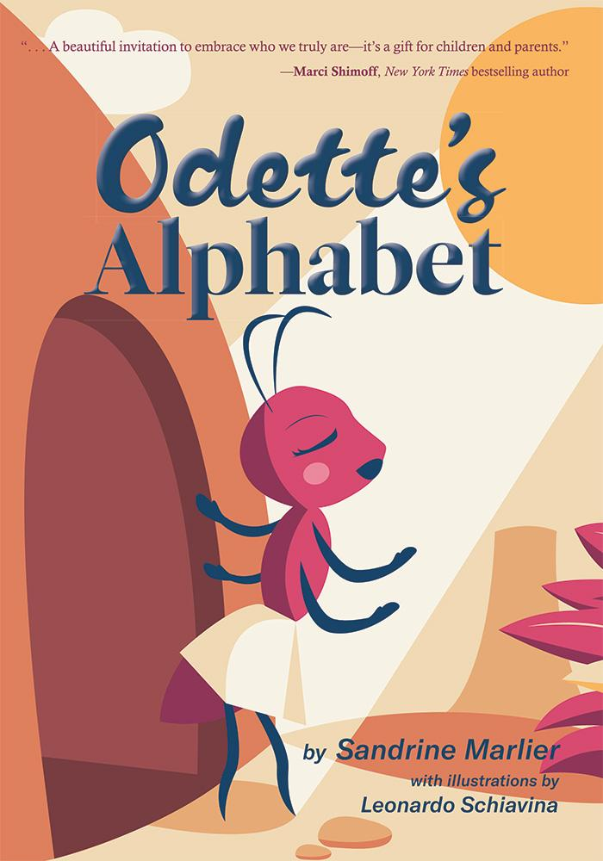](http://www.belleislebooks.com/store/p214/Odette%E2%80%99s_Alphabet.html)

*One day, Odette the ant wakes up feeling stressed. After realizing all she does is work, Odette decides to leave her anthill in search of the freedom to create her own world. Along the way, she meets a lost mouse named Marcus, and together they discover simple ways to feel better. Inspired by her journey and this wonderful new friendship, Odette finds her way home to the colony with a new sense of being.*

Odette’s Alphabet *is a mindful story that offers a map to handle big emotions with kindness, unity, and courage. Fun and easy activities support each of the chapters, along with letters of the alphabet to provide additional opportunities for learning while encouraging young readers to explore meditation practices.*

**About the Author**

[Sandrine Marlier](http://www.belleislebooks.com/sandrinemarlier.html) woke up one day in her New York apartment feeling out of sorts. She realized that no matter how many trips she would take around the world thanks to her modeling career, only a journey within could bring her peace. Eventually she trained with world-renowned meditation teacher davidji. That training inspired this book, as she found herself drawing an ant and a sound: A, the beginning of all beginnings.

Sandrine is a mother, meditation teacher, transformational coach, and Reiki practitioner. She shares free meditations about healing and empowerment on Instagram (@sandrinemarlier). You can connect with her through her website, www.sandrinemarlier.com.

**About the Illustrator**

[Leonardo Schiavina](http://www.belleislebooks.com/leonardoschiavina.html) was born and raised in Italy. In 2014, he moved to Barcelona, Spain, where he obtained his master’s degree and worked for many studios and agencies before founding his own graphic collective, Collettivo Mare, in 2015. He has since worked as an art director and graphic designer for branding, illustration, and editorial design projects from Spain to Israel to the US.

Leo is passionate about aesthetic graphic design and illustration, as well as music and photography, and loves mixing them in a unique and genuine style. A restless nomad who loves living in different countries and cities, he’s currently based in Tenerife in the Canary Islands.

**Interviews available upon request.**

[Belle Isle Books](http://www.belleislebooks.com/), an imprint of [Brandylane Publishers, Inc.](https://brandylanepublishers.com/), is an independent press located in Richmond, Virginia that has published books since 1985.

___________

*Odette’s Alphabet* (paperback, 64 pages, $18.95 / Kindle e-book, $2.99) is available for pre-order from [Amazon](https://www.amazon.com/Bella-Joins-Service-Julie-Williams/dp/1951565193), [Barnes & Noble](https://www.barnesandnoble.com/w/bella-joins-the-service-julie-ellis-williams/1142060073?ean=9781951565190), and other fine booksellers.