**FOR IMMEDIATE RELEASE**

**March 2022**

**Publicity Team**

pr@brandylanepublishers.com

804-644-3090

**This Spring, Head *Off to the Races with Mukha the Dingo*!**

written by Ray Chung

illustrated by Emily Hurst Pritchett

on sale April 11, 2022

“A delightful, feel-good tale with perfectly brilliant illustrations. Put me down as a big Mukha fan!”

- Martin Clark, bestselling author of *The Substitution Order*

[Belle Isle Books](http://www.belleislebooks.com/) of Richmond, Virginia, is pleased to announce the upcoming release of a new children’s book, [*Off to the Races with Mukha the Dingo*](http://www.belleislebooks.com/store/p185/Off_to_the_Races_with_Mukha_the_Dingo.html), written by Ray Chung and illustrated by Emily Hurst Pritchett.

Mukha the dingo wants nothing more than to spend a day of fun at the horse races with her humans. There’s just one problem—dogs aren’t allowed! But that won’t stop this determined little dingo, who soon proves to everyone that she can be the life of the party.

Follow Mukha on a series of madcap capers as she rushes through lush illustrations in this rolicking read for all ages.

*Off to the Races with Mukha the Dingo* is scheduled for release on April 11, 2022.

[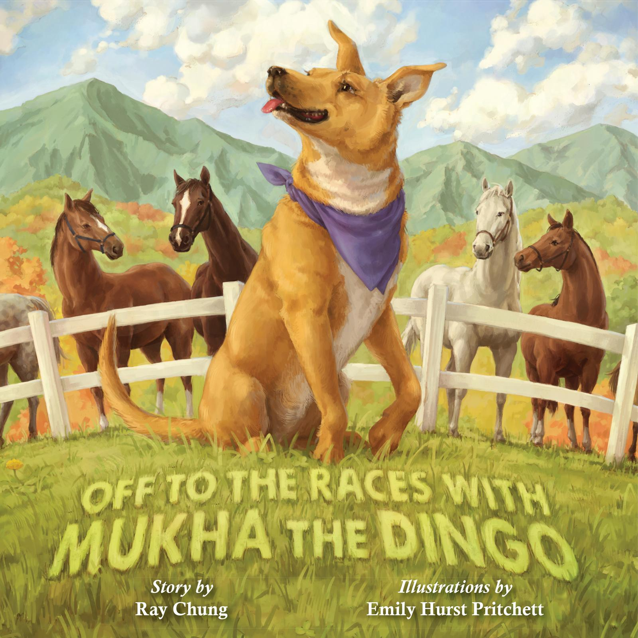](http://www.belleislebooks.com/store/p185/Off_to_the_Races_with_Mukha_the_Dingo.html)

*When a shy but curious dingo named Mukha becomes lost at a horse racing event, she’ll do anything to find her humans. Mukha’s adventure is full of twists and turns as she accidentally runs in a terrier race, unintentionally participates in a fancy hat contest, and inadvertently winds up on the racetrack during the main event! Mukha will delight attendees and surprise race officials, but will she find her humans?*

**About the Author**

[Ray Chung](http://www.belleislebooks.com/raychung.html) is a graduate of the University of Pennsylvania and Jefferson Medical College. A practicing orthopedic hand surgeon who is blessed to live in Virginia’s Piedmont region with his rescue pups, he wishes to share their antics and a glimpse of country life to entertain and enlighten kids around the world. Ray helps maintain Mukha’s Instagram page [@mukhathedingo](https://www.instagram.com/mukhathedingo/?hl=en) in her memory.

**About the Illustrator**

[Emily Hurst Pritchett](http://www.belleislebooks.com/emilyhurstpritchett.html) grew up in western New York and has loved to draw and paint all her life. She studied illustration at Brigham Young University in Utah before moving back to the East Coast. She loves to read books for kids and grown-ups, sing, dance, and play video games. She currently lives in Boston, where she loves to hike in the woods with her husband and son. You can learn more about Emily at her website, [emilypritchettart.com](https://emilypritchettart.com/).

**Interviews available upon request.**

[Belle Isle Books](http://www.belleislebooks.com/), an imprint of [Brandylane Publishers, Inc.](https://brandylanepublishers.com/), is an independent press located in Richmond, Virginia that has published books since 1985.

___________

*Off to the Races with Mukha the Dingo* (hardcover, 36 pages, $24.95 / paperback, 36 pages, $13.95) is available for pre-order from [Amazon](https://www.amazon.com/Off-Races-Mukha-Dingo-Chung/dp/1953021298p/1951565320/), [Barnes & Noble](https://www.barnesandnoble.com/w/off-to-the-races-with-mukha-the-dingo-ray-chung/1140787895?ean=9781953021298r/1138664294?ean=9781951565329), and other fine booksellers. Kindle e-book (retail $2.99) forthcoming.