**FOR IMMEDIATE RELEASE**

**July 2021**

**Christina Kann, Publicist**

[pr@brandylanepublishers.com](mailto:pr@brandylanepublishers.com)

**A cross-generational maritime adventure:**

***Oliver’s Adventure***

**written by Marjorie Masek**

**illustrated by Parks Duffy**

**on sale July 20, 2021**

“This lovely and beautifully illustrated story will surely be enjoyed by anyone who ever had exciting adventures as a child—or those who dreamed of having them. For those of us who share a special love for children, animals, and the river life, the book is magical and very highly recommended!”

*—Kathy Phillips, M.Ed., early childhood specialist at Rural Infant Services Program*

[Belle Isle Books](http://www.belleislebooks.com/) of Richmond, Virginia, is proud to announce the upcoming release of *Oliver’s Adventure*,written by the late Marjorie Masek and illustrated by Parks Duffy. *Oliver’s Adventure* is scheduled for release on July 20, 2021.

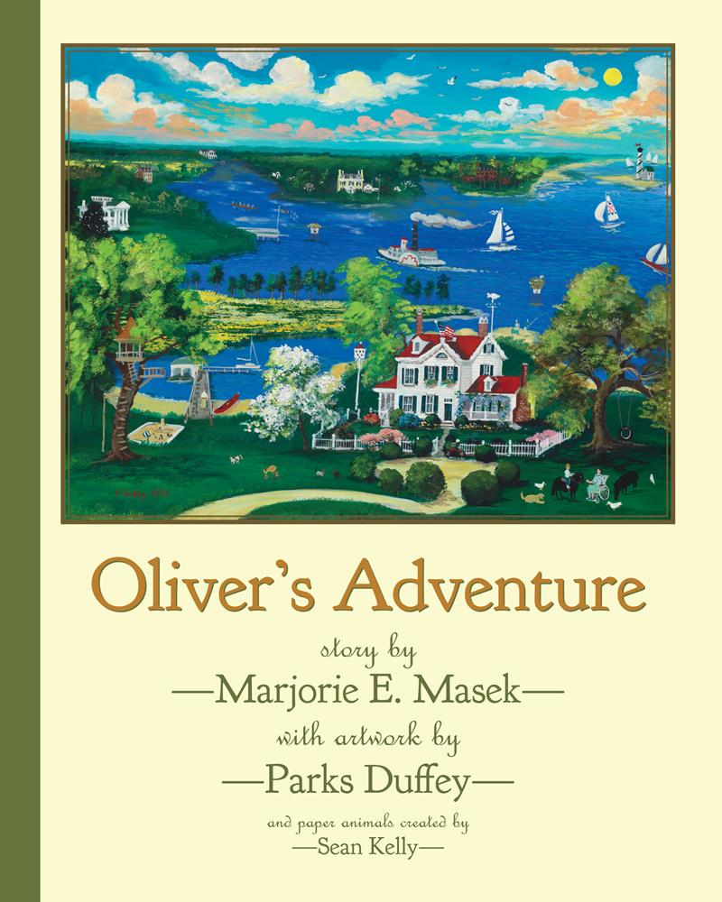

Oliver loves his home among the wildlife of the Chesapeake Bay. But one day, he and his canoe are swept out into the wild waters of the North River. Can he and his animal friends make it back to safety?

**About the Author**

Marjorie Ellen Hayter Masek was born in San Diego, CA, in 1927. Following her education in fashion design, Marjorie met and married LTJG William (Bill) Masek, Jr., USN. Marjorie was a glamorous woman with gourmet cooking skills, a gusto for life, and a generous and gregarious nature. Upon her husband’s retirement in 1975, the couple discovered Gloucester, VA, which they found to be “the land of the life worth living.” She wrote Oliver’s Adventure in 1993 and found an artist who captured her vision; however, the manuscript and art were kept secret from her family while awaiting publication. Unfortunately, Marjorie was unable to get her manuscript published before she died in 2018, when her children discovered the manuscript.

**About the Illustrator**

Self-taught artist Parks Duffey captures the world in a fanciful, colorful, primitive, and yet realistic style. A native of Richmond, Virginia, Parks is well known for his detailed and charming paintings of Virginia’s prestigious colleges, universities, and secondary schools, as well as other architectural landmarks in Virginia, Washington, D.C., the Carolinas, the Caribbean, and Oklahoma City. His unique work is displayed in private and corporate collections around the world, including the White House Historical Association. Some are now available in jigsaw puzzle form.

**Interviews available upon request.**

[Belle Isle Books](http://www.belleislebooks.com/) is a proud imprint of [Brandylane Publishers, Inc.](https://brandylanepublishers.com/), an independent press located in Richmond, Virginia, that has published books since 1985.

_____

*Oliver’s Adventure* (40 pages, hardcover $23.95 / paperback $13.95) is available for pre-order through [Bookshop](https://bookshop.org/books/mr-robert-monkey-returns-to-new-york-9781953021090/9781953021083), [Amazon](https://www.amazon.com/Mr-Robert-Monkey-Returns-York/dp/1953021093/), [Barnes and Noble](https://www.barnesandnoble.com/w/mr-robert-monkey-returns-to-new-york-arnold-johnston/1139093661?ean=9781953021090), and other fine booksellers.