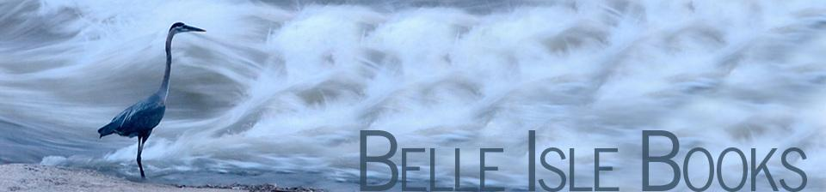

**DATE: August 2015**

**NEWS** (Release Immediately)

**CONTACT:** Publicist, or Robert H. Pruett, Publisher, 804.644.3090; FAX 804.644.3092. Email *brandylanepr@gmail.com* or *rhpruett@brandylanepublishers.com*

**Marine Life Celebrated in New Children’s Book**

Belle Isle Books, an imprint of Brandylane Publishers, Inc. of Richmond, Virginia is excited to announce the release of *Pea Soup and the Seafood Feast*, a new children’s book written by Anna Burger and illustrated by Laura Craig. This adventurous tale for young readers centers on a boy named Jack who scrambles to come up with an alternative when his mother announces that pea soup is on the dinner menu. Jack sets out on the Chesapeake Bay to catch his own seafood feast and discovers a newfound appreciation for sustaining marine life along the way.

After donning his life jacket, Jack grabs his fishing gear and embarks on his first solo seafood adventure. However, Jack soon discovers the beauty of each creature he encounters and decides to leave them in their natural habitat. First-time author Anna Burger incorporates the lessons she learned from her own experiences and shows true appreciation for the knowledge instilled by life on the water. Accompanied by Laura Craig’s vivid watercolor illustrations, *Pea Soup and the Seafood Feast* demonstrates how an exploration and appreciation of one’s natural surroundings can be celebrated and shared from one generation to the next.

Anna Burger lives on Virginia's Eastern Shore with her husband and young son. She grew up on Onancock Creek, where she received her first boat at age 12 and learned how to crab and fish from her father and grandfather. After several years practicing law, she is now following her first love—writing. Laura Craig was raised on the Eastern Shore of Virginia and currently lives with her husband and daughters in Fredericksburg. A hobbyist painter all her life, Craig is now a professional artist.

Belle Isle Books is an imprint of Brandylane Publishers, Inc., an independent press located in Richmond, Virginia, that has published fiction, non-fiction, and poetry since 1985.

**__________________________________________**

*Pea Soup and the Seafood Feast* (Hardcover, 28 pages, $19.95 retail) is available from fine booksellers, online through Amazon, Barnes & Noble, and belleislebooks.com, by calling 804.644.3090, or by writing 5 South First Street, Richmond, VA 23219. **Requests for review copies should be made to the publisher.**