**FOR IMMEDIATE RELEASE**

**March 2020**

**Christina Kann, Publicist**

[brandylanepr@gmail.com](mailto:brandylanepr@gmail.com) or 804.644.3090

**“The path to greatness is treacherous”:**

***Peter Polo and the Snow Beast of Hunza***

**written by Craig Bradley**

**illustrated by Laurie A. Conley**

**on sale April 17, 2020**

“This book is just like the adventures I loved most as a child—exciting, compulsively readable, and with just the right number of twists. I can’t wait to go on more adventures with Peter Polo!” - Leah Grover, bookseller at Bard’s Alley Bookstore, Vienna, Virginia

[Belle Isle Books](http://www.belleislebooks.com/) of Richmond, Virginia is excited to announce the upcoming release of the new middle grade fiction book, [*Peter Polo and the Snow Beast of Hunza*](https://www.amazon.com/Peter-Polo-Snow-Beast-Hunza/dp/1947860968/ref=sr_1_1?keywords=peter+polo+and+the+snow+beast+of+hunza&qid=1581006844&sr=8-1), written by Craig Bradley and illustrated by Laurie A. Conley. A daring adventure to uncover the secrets of the snow beast and save the people of Hunza, *Peter Polo and the Snow Beast of Hunza* is scheduled for release on April 17, 2020.

[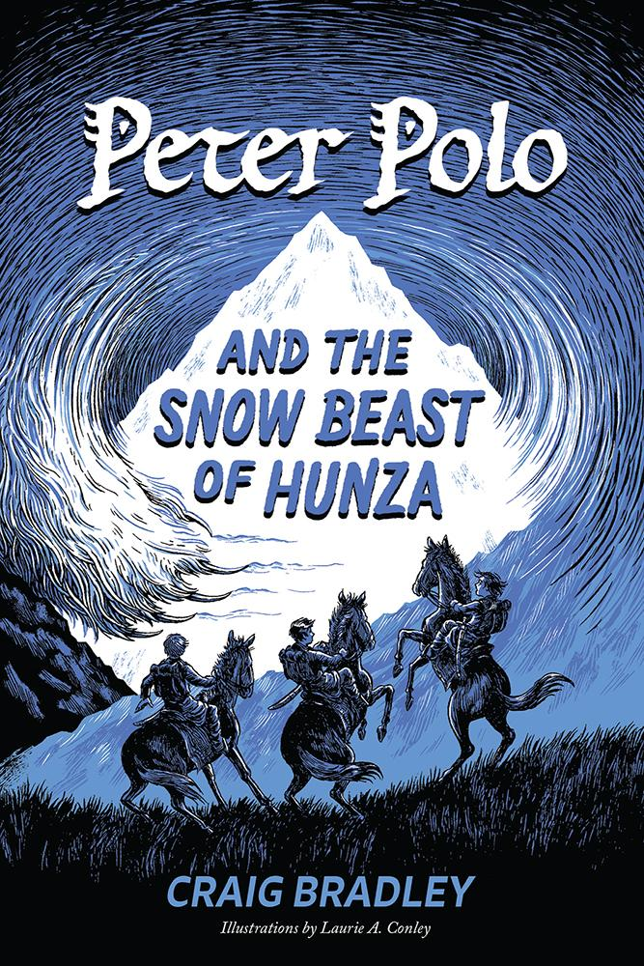](https://www.amazon.com/Peter-Polo-Snow-Beast-Hunza/dp/1947860968/ref=sr_1_1?keywords=peter+polo+and+the+snow+beast+of+hunza&qid=1581006844&sr=8-1)

Peter Polo has been waiting his whole life for this: The Great Khan has sent him on a dangerous quest to the far-off valley of Hunza. Peter finally has a chance to step out of his famous brother’s shadow and into the light of his own adventure. But the path to greatness is treacherous. Someone (or something) is causing the sacred snow leopards to disappear, and the people of Hunza fear the return of a legendary monster known as the Snow Beast. It’s going to take great courage for Peter and his friends to uncover the truth and save the people of Hunza . . . before it’s too late.

**About the Authors**

[Craig Bradley](http://www.belleislebooks.com/craigbradley.html) is an avid hiker and traveler who often chronicles his adventures for his family and friends. He has lived and traveled extensively throughout Asia. Intrigued by the tales of Marco Polo as a child, he often imagined what it might have been like to be Marco’s younger brother—and so Peter Polo was born. Craig currently lives in Virginia with his wife and two sons and travels whenever possible.

**About the Illustrator**

[Laurie A. Conley](http://www.laurieaconley.com) is an artist who specializes in bringing historical scenes to life with pen and ink. Her work has been published extensively in educational materials, as well as in both fiction and nonfiction middle grade books. Laurie earned a BFA from Syracuse University and has illustrated professionally for over thirty years. She and her husband live in Maryland with their youngest son.

**Interviews are available upon request.**

[Belle Isle Books](http://www.belleislebooks.com/) is an imprint of [Brandylane Publishers, Inc](https://brandylanepublishers.com/)., an independent press located in Richmond, Virginia that has published books since 1985.

____________

*Peter Polo and the Snow Beast of Hunza* (middle grade fiction, 108 pages. Hardcover $21.95 / paperback $12.95 / ebook $3.99) is available for pre-order from[Amazon](https://www.amazon.com/Peter-Polo-Snow-Beast-Hunza/dp/1947860968/ref=sr_1_1?keywords=peter+polo+and+the+snow+beast+of+hunza&qid=1581006844&sr=8-1), [Barnes & Noble](https://www.barnesandnoble.com/w/peter-polo-and-the-snow-beast-of-hunza-craig-bradley/1136050488?ean=9781947860971), and other fine booksellers.