**FOR IMMEDIATE RELEASE**

**July 2024**

**Publicity Team**

804-644-3090  
pr@brandylanepublishers.com

***Picking Patch* Invites Young Readers on an Autumn Excursion to Choose a Pumpkin—with Unexpected Results**

written by Diane Twomley

illustrated by Cheryl Grant

on sale July 23, 2024

“A joyous way to ring in the fall season that is full of heart. Not just an autumn treat, but also a book that will please the animal lover within us all.”

- Jeff Mayer, author of *The Little Green Pumpkin*

[Belle Isle Books](http://www.belleislebooks.com/) of Richmond, Virginia, is pleased to announce the upcoming release of a new children’s picture book, [*Picking Patch*](https://www.belleislebooks.com/store/p235/Picking_Patch.html)*,* written by Diane Twomley and illustrated by Cheryl Grant.

Picking a pumpkin from the pumpkin patch is a cherished fall tradition for many families. When a young boy named Casey arrives at Mrs. Franny’s farm, he’s excited to participate in that tradition and find his own pumpkin to carve. But as his family enjoy the farm’s many activities—from wagon rides to sitting on a truly enormous pumpkin—they soon discover that a small furry friend might also be picking them!

Resplendent with watercolor illustrations that celebrate the warm hues of the fall season and the family with whom we share it,*Picking Patch* is scheduled for release on July 23, 2024.

[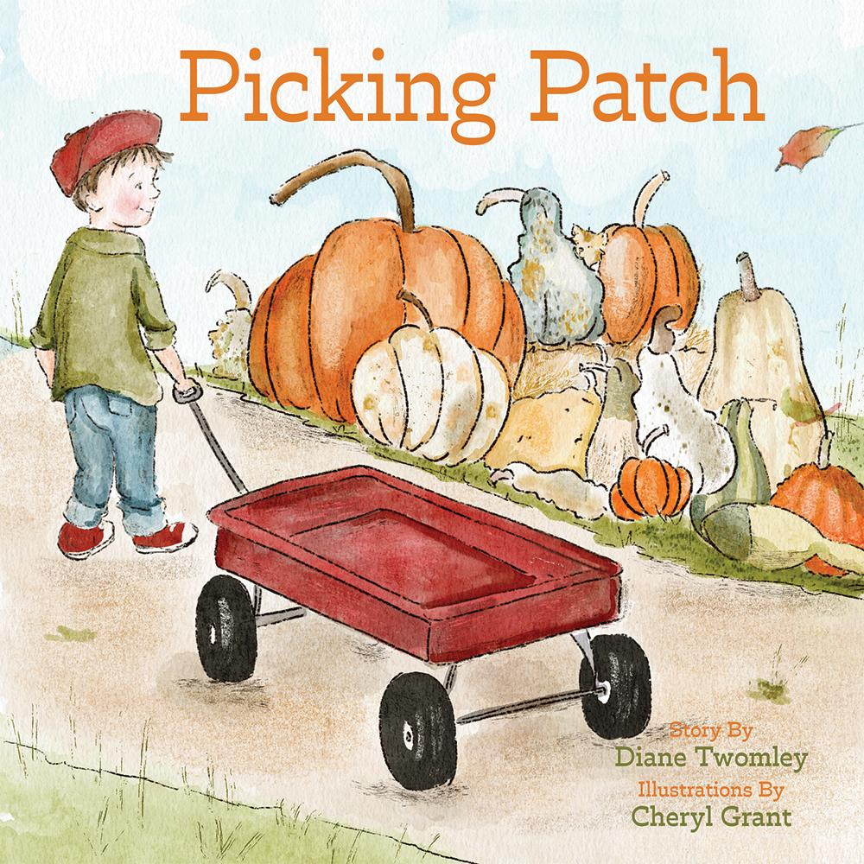](https://www.belleislebooks.com/store/p235/Picking_Patch.html)

*Casey is so excited to pick out a pumpkin at the pumpkin patch. There are so many kinds to look at—from round and bumpy to skinny and smooth! As Casey makes his way through the patch, he spots a new friend hiding under a wagon, peeking out from behind gourds, and even sitting on top of the pumpkin he decides to choose. At the end of the day, a pumpkin isn’t the only thing Casey picks at the patch. Based on a true story,* Picking Patch *is the perfect fall read for pumpkin and animal lovers alike.*

*Check the illustrations on each page to see a furry friend lurking in the background!*

**About the Author**

[Diane Twomley](https://www.belleislebooks.com/dianetwomley.html) is the author of children’s books *Carole Jane from Starfish Lane* and *Picking Patch.* She is a mother and grandmother who has an interesting laugh and always sees a silver lining, even when others don't.

Some of Diane’s favorite things are books, jelly doughnuts, cozy pajamas, the ocean, and the laughter of little children. She believes that you are never too old to try something new, like writing a book.

Diane has always worked in jobs that allow her to help others. She spent almost twenty-five years in a middle school library, where her favorite thing was helping students find the perfect book.

Diane lives in central Pennsylvania with her husband, Mike. They have raised two wonderful sons and treasure every moment with their grandson, Harper T.S. *Picking Patch* is based on the true story of how Diane and her husband met their cat.

**About the Illustrator**

[Cheryl Grant](https://www.belleislebooks.com/cherylgrant.html) was born and raised in the mountains of Virginia. Simple country living and love of family influence many of her illustrations.

Cheryl attended Mary Baldwin University, graduating in 1990 with an art degree. When her son was born, she decided to stay home with him. During this time, she continued to create treasured art for friends and family.

Cheryl returned to work in the early 2000s, creating a popular website that made her art available for digital download. Some of her most popular illustrations feature her adorable puppy, her two cats, and their sassy adventures.

Cheryl now enjoys spending time with her grandson and watching him grow. *Picking Patch* is her second illustrated book.

**Interviews available upon request.**

[Belle Isle Books](http://www.belleislebooks.com/), an imprint of [Brandylane Publishers, Inc.](https://brandylanepublishers.com/), is an independent press located in Richmond, Virginia that has published books since 1985.

___________

*Picking Patch* (hardcover, 36 pages, $26.95 / paperback, 36 pages, $15.95) is available for pre-order from [Amazon](https://www.amazon.com/Picking-Patch-Diane-Twomley/dp/1962416224), [Barnes & Noble](https://www.barnesandnoble.com/w/picking-patch-diane-twomley/1144495585?ean=9781962416221), and other fine booksellers.