**FOR IMMEDIATE RELEASE**

**April 2020**

**Christina Kann, Publicist**

[brandylanepr@gmail.com](mailto:brandylanepr@gmail.com) or 804.644.3090

**Faith and Friendship in *Pinky Swear***

**written by Diane Wright Forti**

**illustrated by Maryana Kachmar**

**on sale May 20, 2020**

"*Pinky Swear* is a beautiful and uplifting story about the importance of friendship, unconditional love, overcoming adversity, and having faith."

—Journey Johnson, retired YMCA CEO

[Belle Isle Books](http://www.belleislebooks.com/) of Richmond, Virginia, is excited to announce the upcoming release of the new children’s book, [*Pinky Swear*](https://www.amazon.com/Pinky-Swear-Diane-Wright-Forti/dp/1951565355/ref=sr_1_5?keywords=pinky+swear+belle+isle+books&qid=1583334888&sr=8-5), written by Diane Wright Forti and illustrated by Maryana Kachmar. A charming story about a young girl’s journey to acceptance and faith, *Pinky Swear* is scheduled for release on May 20, 2020.

When Maggie moves away, she and her mother pinky swear that she will still be able to see her best friend Brooke as often as possible. But Maggie was born with only one arm, and nobody in her new town understands her. When Maggie discovers a lost pink dolphin living in the river by her new house, she learns that she is not the only one feeling lonely. She names the dolphin Paddy and visits her every day. But when the weather turns cold and Paddy gets sick, Maggie must choose between keeping her new friend close, and letting her go. Join Maggie in this story of acceptance, faith, and friendship, and learn about the many ways that we can all reach out to save each other!

[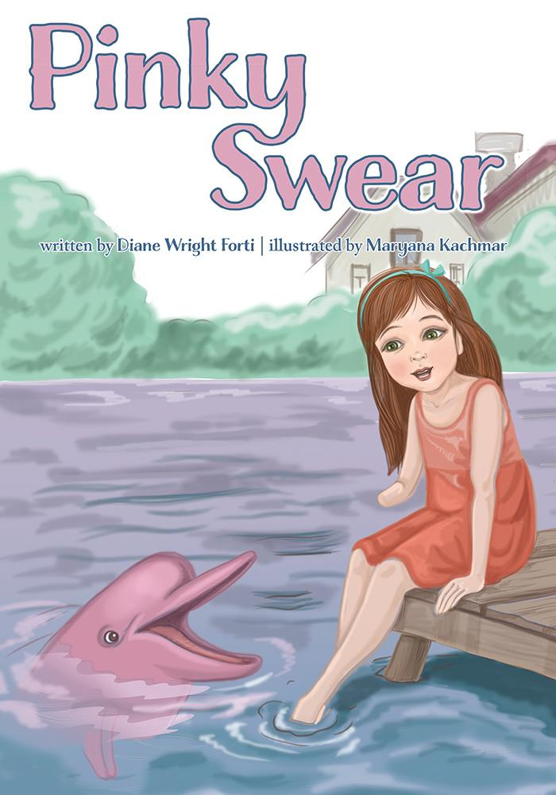](https://www.amazon.com/Pinky-Swear-Diane-Wright-Forti/dp/1951565355/ref=sr_1_5?keywords=pinky+swear+belle+isle+books&qid=1583334888&sr=8-5)

**About the Author**

[Diane Wright Forti](http://www.belleislebooks.com/dianeforti.html) has been an RN for twenty-nine years. She was born and raised in Richmond, VA, where she still lives today with her husband. They have a combined family of six grown children and nine grandchildren, who all live within babysitting distance. *Pinky Swear* is her first book. Diane is currently working on her next children’s book, based on her true-life adoption story.

**About the Illustrator**

[Maryana Kachmar](http://www.belleislebooks.com/maryanakachmar.html) was born in Lviv, Ukraine in 1983. She is a certified Master of Sacred Art, and the founder of the Christian children’s magazines “Angel” and “Flashlight,” where she has worked as editor and artist. She has also illustrated many children’s books. Maryana loves the smell of flowers in the spring and appreciates every moment given to her by God. She is the mother of three cheerful and energetic children, who inspire her daily with new pictures!

**Interviews are available upon request.**

[Belle Isle Books](http://www.belleislebooks.com/) is an imprint of [Brandylane Publishers, Inc](https://brandylanepublishers.com/)., an independent press located in Richmond, Virginia that has published books since 1985.

____________

*Pinky Swear* (children’s book, 36 pages. Hardcover $22.95 / paperback $13.95 / e-book $2.99 forthcoming) is available for pre-order from[Amazon](https://www.amazon.com/Pinky-Swear-Diane-Wright-Forti/dp/1951565355/ref=sr_1_5?keywords=pinky+swear+belle+isle+books&qid=1583334888&sr=8-5), [Barnes & Noble](https://www.barnesandnoble.com/w/pinky-swear-diane-wright-forti/1136403824?ean=9781951565367), and other fine booksellers.