**FOR IMMEDIATE RELEASE**

**January 2019**

**Christina Kann, Publicist**

brandylanepr@gmail.com or 804.644.3090

**Find Your Inner Calm with *The Power in Me***

**written by Meaghan Axel**

**illustrated by Michelle Simpson**

**on sale now!**

“*The Power in Me* offers an invaluable reminder to us all: to be still, to breathe,

and to recognize the strength within us. This gentle reminder about

mindfulness will find a home at story times and bedtimes.”

*—Matthew C. Winner, school librarian and host of “The Children’s Book Podcast”*

[Brandylane Publishers, Inc.](http://brandylanepublishers.com/) of Richmond, Virginia is excited to announce the upcoming release of Meaghan Axel’s new children’s book, [*The Power in Me*](https://www.amazon.com/Power-Me-Meaghan-Axel/dp/1947860828/ref=sr_1_1?keywords=the+power+in+me&qid=1578418416&sr=8-1). A charming, whimsical guide to a young child’s meditation and breath work, *The Power in Me* is scheduled for release in January.

*Are your thoughts in a tizzy? Doubts making you dizzy? Tell those feelings to shoo with the power in you! Y*oung or old, we all have problems that weigh on our minds. Learn how to keep your cool and controlyour thoughts on even the toughest days with this delightful book about the power of breath.

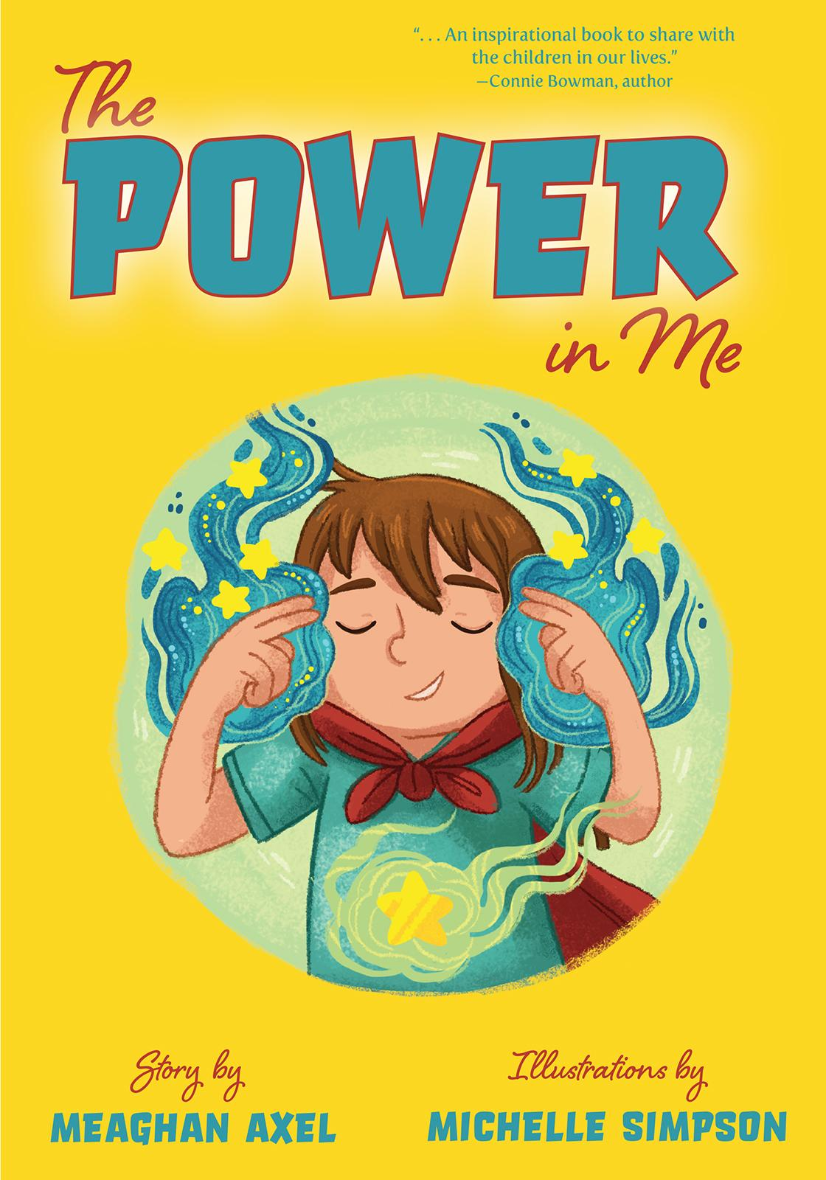

**About the Author**

[Meaghan Axel](https://meaghanaxel.weebly.com/) was a secondary English teacher for many years before her passion for learners and children’s literature led her to where she truly belongs—the elementary school library. After dabbling with yoga and meditation for some time, Meaghan became a certified yoga instructor in 2014. She enjoys sharing her love for reading, yoga, and meditation with others. Mrs. Axel lives on the beautiful Eastern Shore of Maryland with her husband and daughter.

**About the Illustrator**

[Michelle Simpson](http://www.michellescribbles.com/) is a professional illustrator based out of the Niagara Region of Canada. Michelle graduated with a BAA in illustration from Sheridan College, and now works as a freelance illustrator. She has worked on concept artwork and final backgrounds for season two of the children’s TV show *Ollie: The Boy Who Became What He Ate*. She also worked on season one of *Tee and Mo*. Although she takes on many different projects, Michelle’s passion is children’s book illustration.

**Interviews are available upon request.**

Brandylane Publishers, Inc. is an independent press located in Richmond, Virginia that has published books since 1985.

____________

*The Power in Me* (children’s fiction, 32 pages. Hardcover $21.95 / paperback $13.95 / ebook $4.99) is available for pre-order from [Brandylane Publishers](http://brandylanepublishers.com/wp/book/list-all/fiction-literature/the-precariouness-of-done-by-tony-houck/), [Amazon](https://www.amazon.com/Power-Me-Meaghan-Axel/dp/1947860828), [Barnes & Noble](https://www.barnesandnoble.com/w/the-power-in-me-meaghan-axel/1133433308?ean=9781947860834), and other fine booksellers.