**FOR IMMEDIATE RELEASE**

**April 2024**

**Publicity Team**

pr@brandylanepublishers.com

804-644-3090

**New Novel *Raptors in the Ricelands* Interweaves History and Fiction to Celebrate Author’s Gullah Geechee Heritage**

written by Ron Daise

on sale April 30, 2024

“. . . a genre-defying narrative of good intentions gone wrong, rich with Gullah culture and language that highlights our connections through the Caribbean and African diasporas.”

- Eden Royce, award-winning author of *Root Magic*

[Belle Isle Books](http://www.belleislebooks.com/) of Richmond, Virginia, is pleased to announce the release of a new work of fiction, [*Raptors in the Ricelands*](https://www.belleislebooks.com/store/p239/Raptors_in_the_Ricelands.html), written by Ron Daise.

The Gullah Geechee people are the descendants of enslaved West Africans brought to a young America from West Africa to work the rice plantations that dominated the swampy, cypress-tree-dotted coasts and islands from present-day North Carolina to Florida. In 2006, the US government designated the area the Gullah Geechee Cultural Heritage Corridor, providing funds to help the Gullah Geechee preserve historic Lowcountry sites with the assistance of the US National Park Service. The government’s Act recognized the Gullah people’s success in maintaining the resilient cultural traditions of their West African ancestors, including not only their unique African-based creole language—the only one of its kind in the US, and one not unlike the patois of their cousins in the diaspora who were brought to Jamaica—but also their crafts, religious rituals, and foodways. Daise served as chairman of the GGCHCC during the launch of the Corridor’s Management Plan.

In *Raptors in the Ricelands,* Gullah Geechee native—or, in Gullah Geechee terms, “beenyah”—Ron Daise shines a light on a fictional Gullah Geechee community in Georgetown, SC, the lives of its residents—and the motives of those people who would take advantage of them.Told in vignettes spanning six decades from 1960 to the modern day, his nonlinear four-part tale interweaves accounts of true historical events alongside the trials and heartbreaks faced by both beenyahs and comeyahs—outsiders who have moved to historic Gullah Geechee ricelands, communities near former rice fields where rice heritage thrives:

Chadwick Wineglass is a beenyah who, thanks to his parents’ tutelage, has always been acutely aware of how white people perceive his people’s unique, rhythmic speech. A visionary and entrepreneur, he dreams of economic success that will allow him to enrich his neighbors—but finds his good intentions marred by the insidiously attractive promises of investors who would profit at the expense of his community, as well as by his own raptor-like views of how best to practice philanthropy.

Florence Wineglass, Chadwick’s wife, grapples with infertility and the revelation of her grandfather’s infidelity as her marriage begins to suffer.

Thelma Marshel, a comeyah, wrestles with her unfamiliarity with her new husband’s Gullah culture, and struggles with her own controlling nature as she attempts to maintain their relationship.  
 Thelma’s brother Timothy Thunderbolt, a comeyah and fervent pastor who struggles to reconcile his staunch Christian views with the traditional beliefs and healing also practiced in the community to which he now preaches, learns the beauty of Gullah Geechee spirituality. Meanwhile, his wife, Sibyl Thunderbolt, a comeyah with Native American heritage, finds a familial connection in her and Timothy’s new church community.

These are only a few of the richly detailed characters who people the Lowcountry of Daise’s novel—a novel that challenges even as it educates, examining such questions as the true extent of a benefactor’s obligation, how a Christian church and its leaders can best inspire a community, the means by which families are tied together, and the ways the pains suffered by a people can linger in their descendants’ bodies and present conflicts. And throughout, Daise brings his expertise as a member of the team that translated the language for the Gullah Bible to bear as he lovingly craftspassages rich with the Gullah accent, as well as Gullah customs, beliefs, and lifestyles.

A thought-provoking, poetic, poignantly emotional saga for beenyahs, comeyahs, and those who have never set foot in South Carolina’s Lowcountry,*Raptors in the Ricelands* is scheduled for release on April 30, 2024.

[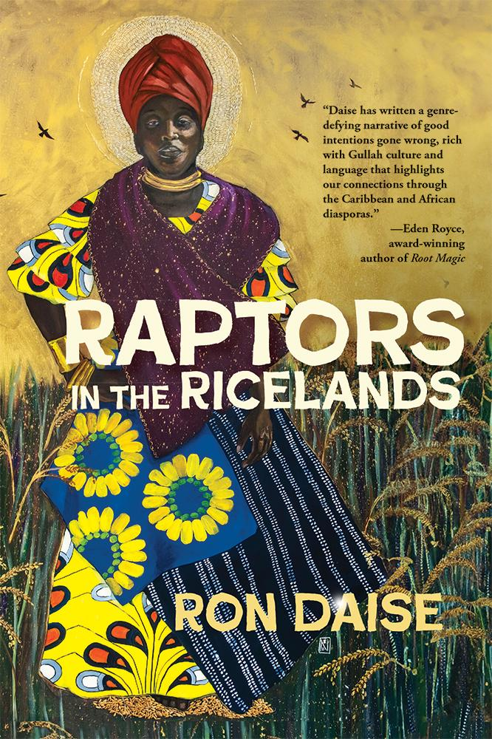](https://www.belleislebooks.com/store/p239/Raptors_in_the_Ricelands.html)

*In a fictional twenty-first century version of the community of Georgetown, SC, a story unfolds revealing family secrets and conflicts that challenge cultural beliefs. With bighearted intention, newlyweds Florence and Chadwick Wineglass attempt to promote economic legacy, but their unconscious motives often ensnare those they assist. The Wineglasses become raptor-like in their generosity at a moment when other community members’ intentions also prove to be menacing.*

*Conveyed in four acts and with chapter names that follow the production stages of Carolina Gold Rice,* Raptors in the Ricelands *spans the future, the present, and the past, and fosters a message of connection with African diasporic communities around the globe. Historical accounts include the Orangeburg Massacre; Black church life, particularly in Oconee County, SC as begun during slavery; the launch of White supremacy in Fort Mill, SC; the Reconstruction Era; and the Universal Negro Improvement Association.*

**About the Author**

[Ron Daise](https://www.belleislebooks.com/rondaise.html), a son of St. Helena Island, SC, is an author, performer, educator, and cultural interpreter whose books, productions, and recordings have documented and shaped Gullah Geechee heritage since 1986. A graduate of Hampton Institute (now Hampton University) and co-star of *Gullah Gullah Island*, Nick Jr. TV’s award-winning children’s program of the 1990s, Ron also is a former chairman of the federal Gullah Geechee Cultural Heritage Corridor Commission, and is featured in exhibits at the International African American Museum, Charleston, SC; the Smithsonian National Museum of African American History and Culture, Washington, DC; and Brookgreen Gardens, Murrells Inlet, SC. In addition, he is a baker and owner of Mr. Ron’s Gullahlicious Pound Cakes.

Ron and his wife Natalie reside in Georgetown, SC, and are parents of two adult children. Ron can be found online at www.rondaise.com, on Instagram @gullahron, and on Meta @rondaise.

**Interviews available upon request.**

[Belle Isle Books](http://www.belleislebooks.com/), an imprint of [Brandylane Publishers, Inc.](https://brandylanepublishers.com/), is an independent press located in Richmond, Virginia that has published books since 1985.

___________

*Raptors in the Ricelands* (hardcover, 312 pages, $32.95 / paperback, 312 pages, $21.95 / Kindle e-book, $10.99) is available for sale from [Amazon](https://www.amazon.com/Raptors-Ricelands-Ron-Daise/dp/1958754811), [Barnes & Noble](https://www.barnesandnoble.com/w/raptors-in-the-ricelands-ron-daise/1144841549?ean=9781958754818), and other fine booksellers.