**FOR IMMEDIATE RELEASE**

**October 2021**

**Publicity Team**

pr@brandylanepublishers.com

804-644-3090

**Rise Up and Speak Out with *Roly-Poly Prole*!**

written by Elizabeth Javidan

illustrated by Mary Barrows

on sale November 5, 2021

*The Ticks were the leaders, and every Prole knew*

*because of the Ticks, the Proles’ lives were blue!*

[Belle Isle Books](http://www.belleislebooks.com/) of Richmond, Virginia, is pleased to announce the upcoming release of a new children’s book, [*Roly-Poly Prole*](http://www.belleislebooks.com/store/p175/rolypolyprole.html), written by Elizabeth Javidan and illustrated by Mary Barrows.

Along with a uniquely unusual—but nevertheless remarkably relatable—protagonist, this gently illustrated tale also provides an important lesson in socioeconomic structures and the necessity of activism that could easily be incorporated into a classroom curriculum. *Roly-Poly Prole* is scheduled for release on November 5, 2021.

[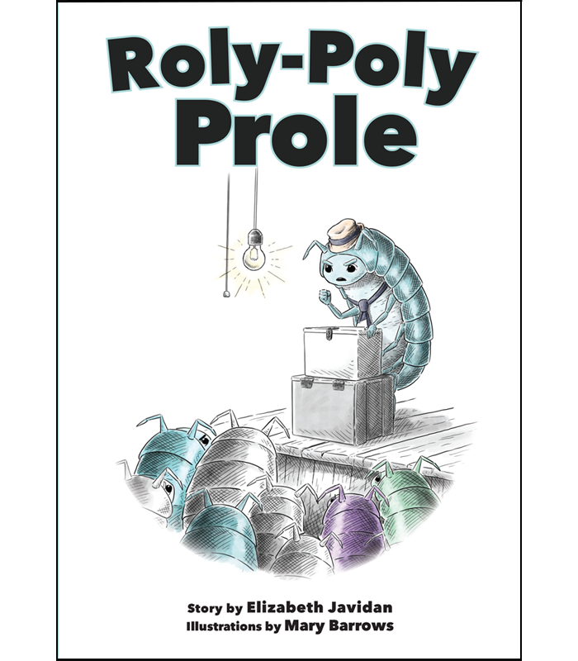](http://www.belleislebooks.com/store/p175/rolypolyprole.html)

*Roly-Poly Prole and his prole neighbors live under the tyranny of the terrible Ticks. Finally Roly-Poly Prole decides that enough is enough, and it’s time to take control of the future. Rise up and speak out with our tiny hero, and learn that change is possible when good people come together.*

**About the Author**

[Elizabeth Javidan](http://www.belleislebooks.com/elizabethjavidan.html) is a teacher turned author who loves books so much, she decided to write one. After encountering dozens of stories about life, hardship, and what it means to never give up on a dream of happiness as an award-winning newspaper columnist, Javidan wanted to honor and congratulate those who, like her character, challenged what they knew was wrong and chose to persevere. She has interwoven her passions for equal rights, twentieth-century dystopian novels, and rhythmic poetry into her debut children’s book, *Roly-Poly Prole*.   
 In her “spare time,” Javidan enjoys cooking, exercising, drinking copious amounts of coffee, and keeping up with her really, really cool kids.

**About the Illustrator**

[Mary Barrows](http://www.belleislebooks.com/marybarrows.html) is a freelance illustrator from Maryland who loves fantasy stories and creatures. Since she was old enough to hold a crayon, she has been drawing pictures from her favorite stories, and she has not stopped yet.   
 Mary works both digitally and traditionally and uses a variety of mediums in her work including gouache, ink, watercolor, and colored pencil. To contact her, visit [www.marybarrows.wordpress.com](http://www.marybarrows.wordpress.com) or email her at [marybarrowsillustration@gmail.com](mailto:marybarrowsillustration@gmail.com).

**Interviews available upon request.**

[Belle Isle Books](http://www.belleislebooks.com/), an imprint of [Brandylane Publishers, Inc.](https://brandylanepublishers.com/), is an independent press located in Richmond, Virginia that has published books since 1985.

___________

*Roly Poly Prole* (hardcover, 32 pages,$23.95 / paperback, 32 pages, $13.95) is available for pre-order from [Amazon](https://www.amazon.com/Roly-Poly-Prole-Elizabeth-Javidan/dp/1953021239), [Barnes & Noble](https://www.barnesandnoble.com/w/roly-poly-prole-elizabeth-javidan/1140034832?ean=9781953021236), and other fine booksellers. Kindle e-book (retail $2.99) forthcoming.