**FOR IMMEDIATE RELEASE**

**August 2022**

**Publicity Team**

pr@brandylanepublishers.com

804-644-3090

This Fall, Gather ’Round the Campfire and Pay Homage to the Earliest Form of Storytelling with *The Song of Circe and Other Simple Musings*

written by J. Matthew Helms

on sale September 14, 2022

*Here lies a tale of two beset in naught but simple words.  
Of the one, he is but a common western wanderer;  
And of her, possessing a radiance unmatched by all else;  
Who were perchance to meet in spite of distant, foreign shores.*

*-* from *The Song of Circe*

[Belle Isle Books](http://www.belleislebooks.com/) of Richmond, Virginia, is pleased to announce the upcoming release of a new book of poetry, [*The Song of Circe and Other Simple Musings*](http://www.belleislebooks.com/store/p198/The_Song_of_Circe_and_Other_Simple_Musings.html), written by J. Matthew Helms.

*The mariner’s star whispers to the waking crescent moon,*

*Asking to hear the song that’s only sung in lunar tune.*

*Of Circe, the Dragon Queen, from the eastern meadow lands*

*And the softly howling wolf that fell helpless in her hands.*

So begins this collection of epic narrative poetry exploring ancient Greek and Norse myths through the lens of modern emotions. A speculative reimagining of the fantasy and folklore found in humanity’s first legends, it beckons readers to sit around the fire, remedy the darkness with matches, and find sculptures in the flame as they watch the embers dance.

A stunning debut, *The Song of Circe and Other Simple Musings* is scheduled for release on September 14, 2022.

[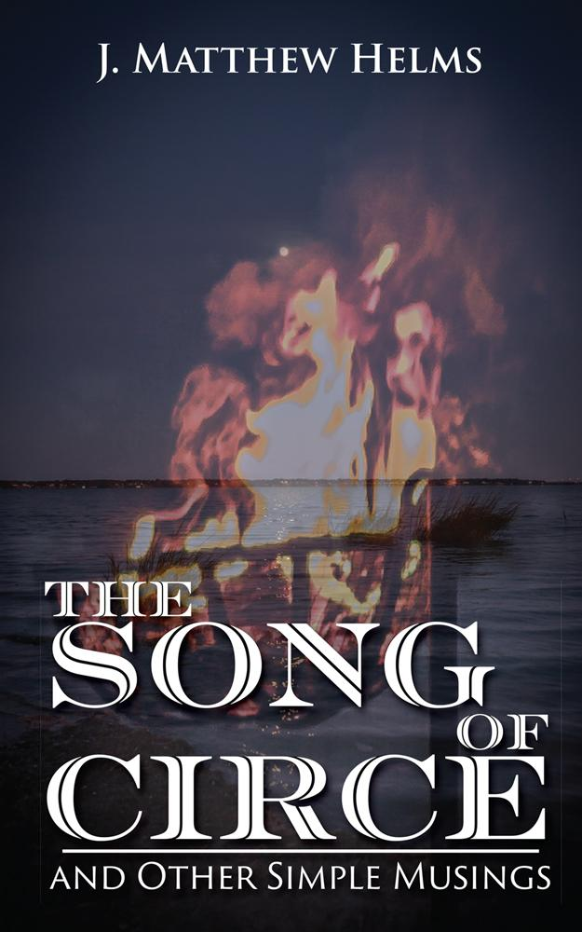](http://www.belleislebooks.com/store/p198/The_Song_of_Circe_and_Other_Simple_Musings.html)

*Twilit dreamscapes unfold across J. Matthew Helms’ debut collection of poetry, revealing new worlds beyond the veils of myth. From the shores of Valhalla to the great halls of Mount Olympus, these unique poems guide the reader through the mists of time and legend like a lantern, casting tales of the old gods in a new light. Interwoven with themes of earthly nature and celestial warfare,* The Song of Circe *reflects the joy and sorrow—the pain and healing—the love and disdain that define the human soul, beckoning us to explore within ourselves the darkest corners of our oldest legends.*

**About the Author**

[J. Matthew Helms](http://www.belleislebooks.com/jmatthewhelms.html) was born and raised in Richmond, VA. A husband, father of two sons, and the project manager of a custom construction company, he has also been a writer of poetry for as long as he can recall. He believes in the stories that can be told, the imagery that can be conveyed, and how each one is inherently tailored to the mind's eye of the reader.

While poetry has been a part of his self-expression for many years, it became a lifeline just over five years ago when he made the choice to become sober. His poetry often reflects the wide range of emotions that come from battling addiction. Many others are inspired by his best friend and companion, his wife of nearly twenty years.

​ When he isn’t writing, working, or spending time with his family, J. Matthew can often be found wandering Richmond with a camera in his hand. His photography has been featured in a number of local shows and galleries.

**Interviews available upon request.**

[Belle Isle Books](http://www.belleislebooks.com/), an imprint of [Brandylane Publishers, Inc.](https://brandylanepublishers.com/), is an independent press located in Richmond, Virginia that has published books since 1985.

___________

*The Song of Circe and Other Simple Musings* (paperback, 164 pages, $14.95) is available for pre-order from [Amazon](https://www.amazon.com/Song-Circe-Other-Simple-Musings/dp/1953021670), [Barnes & Noble](https://www.barnesandnoble.com/w/the-song-of-circe-and-other-simple-musings-j-matthew-helms/1141467564?ean=9781953021670), and other fine booksellers. Kindle e-book (retail $4.99) forthcoming.