**FOR IMMEDIATE RELEASE**

**June 2023**

**Publicity Team**

pr@brandylanepublishers.com

804-644-3090

***That You Remember* Tells the Story of a Mining Town You Won’t Soon Forget**

written by Isabel Reddy

on sale June 9, 2023

“As thoughtful as it is evocative . . . an ode to a region, an elegy for a tidal wave of destruction, vivid and haunting, full of life and loss alike.”

- Judy Goldman, author, *Child: A Memoir*

[Belle Isle Books](http://www.belleislebooks.com/) of Richmond, Virginia, is pleased to announce the upcoming release of a new work of historical fiction, [*That You Remember*](http://www.belleislebooks.com/store/p215/That_You_Remember.html), written by Isabel Reddy.

In this novel of idealistic aspirations and ecological upheaval spurred respectively by young love and corporate greed*,* first-time author Isabel Reddy finds romance in the hardscrabble world of smalltown Appalachia. There, blue-collar workers eke out a harsh existence, and the hopes, passions, and struggles of the local coal miners clash with those of the people who employ them.In this dramatically rendered landscape, a taboo romance between an absentee mine owner and a beautiful local waitress introduces a spark of sympathy to the former’s coldly corporate view, and hope emerges as love inspires better intentions. But in the world of business, even thebest of intentions may not prove to be enough to prevent an imminent disaster.

With page-turning prose full of striking imagery and vivid characterization, thisbig-hearted novel about humble salt-of-the-earth folks sheds light on the daily struggles of Appalachian miners and the corporate corruption they faced, and provides a compassionate view of the world that we should all take care to remember.

Based in part on the true story of the 1972 dam failure in Buffalo Creek Hollow, West Virginia, and meticulously researched,*That You Remember* is scheduled for release on June 9, 2023.

[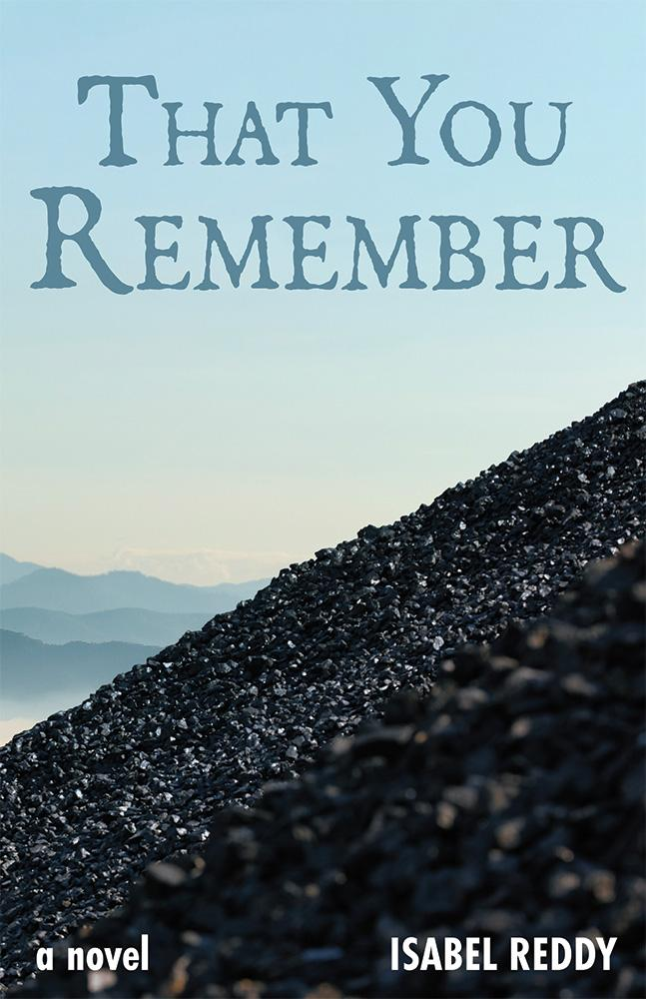](http://www.belleislebooks.com/store/p215/That_You_Remember.html)

*In 2019, adrift in the wake of a failed marriage, Aleena Rowan receives a box of her father's desk diaries from the years he worked as a coal executive. She expects to find nothing more than the cost of business lunches and meeting notes. Instead, she finds a mysterious name — Sara — scrawled on a slip of paper in her father’s handwriting.*

*Frank Rowan meets Sara Stone while fishing on a frigid January day, and sees her again waiting tables at Otter Creek’s only restaurant. It is 1970, and Frank and Sara’s relationship grows despite the impossible distance between a New York corner office and a Kentucky coal hollow. Initially, Sara sees Frank as her ticket to a better life, but other forces compete with her dreams — like protecting her town from the increasingly perilous coal slurry dam.*

*In her debut novel, told from both sides of the coal industry, Isabel Reddy brings to life the conflicts and undercurrents of an Appalachian mining town on the eve of disaster.*

**About the Author**

[Isabel Reddy](http://www.belleislebooks.com/isabelreddy.html) began her career in clinical research as a science writer. She has been a guest columnist for numerous newspapers, and she is working on her MFA in Creative Writing at Goddard College. Ms. Reddy lives in North Carolina with her husband and German shepherd, Mac. *That You Remember* is her first novel.

**Interviews available upon request.**

[Belle Isle Books](http://www.belleislebooks.com/), an imprint of [Brandylane Publishers, Inc.](https://brandylanepublishers.com/), is an independent press located in Richmond, Virginia that has published books since 1985.

___________

*That You Remember* (hardcover, 254 pages, $30.95 / paperback, 254 pages, $17.95) is available for pre-order from [Amazon](https://www.amazon.com/That-You-Remember-Isabel-Reddy/dp/1958754064), [Barnes & Noble](https://www.barnesandnoble.com/w/that-you-remember-isabel-reddy/1143084301?ean=9781958754061), and other fine booksellers. Kindle e-book (retail $7.99) forthcoming.