**FOR IMMEDIATE RELEASE**

**February 2020**

**Christina Kann, Publicist**

brandylanepr@gmail.com or 804.644.3090

**“When it is dark enough, you can see the stars”:**

***Verities: A Journey by Tracks***

**by Randy White**

**on sale March 4, 2020**

“Fast-paced, with unexpected but clever plot twists,

*Verities* carries the reader along with its stand-out characters every inch of the way.”

—Rich Garon, author of *Felling Big Trees* and *Lee Fitts*

[Belle Isle Books](http://www.belleislebooks.com/store/p145/verities.html) is excited to announce the release of [*Verities: A Journey by Tracks*](https://www.amazon.com/Verities-Journey-Tracks-Randy-White/dp/1951565045/ref=tmm_pap_swatch_0?_encoding=UTF8&qid=1582663503&sr=8-1) by Randy White. Follow Sam’s journey into adulthood and his quest for meaning in his troubled life. *Verities: A Journey by Tracks* is scheduled for release March 4, 2020.

[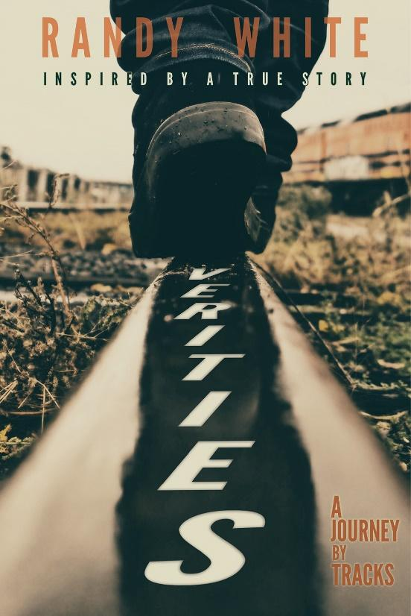](https://www.amazon.com/Verities-Journey-Tracks-Randy-White/dp/1951565045/ref=tmm_pap_swatch_0?_encoding=UTF8&qid=1582663503&sr=8-1)

“When it is dark enough, you can see the stars.” Take a ride down the train tracks in the small town of Verities, and you’ll see one young man’s quests for meaning in his troubled life. Follow Sam’s journey as he grows up facing ugly truths about love and loss on the wrong side of the tracks. Verities is a hopeful story of rising above one’s circumstances, even in the cruel face of social injustice.

**About the Author**

[Randy White](http://www.belleislebooks.com/randywhite.html) founded and serves as executive director of Love of Learning, a nonprofit that hosts read-alouds and donates high-quality children’s books to low-income kids in central Virginia. He has received numerous Making a Difference awards for his work promoting literacy opportunities for disadvantaged children. Before founding his nonprofit organization, Mr. White spent ten years as a public school teacher in a suburb of Richmond, Virginia. He holds a master’s degree in teaching and a bachelor’s degree in sociology from Virginia Commonwealth University, as well as an associate’s degree in social sciences. A native of Richmond, Mr. White currently lives in the city with his wife, Christin, their two young children, and two adorable boxers.

**Interviews are available upon request.**

[Belle Isle Books](http://www.belleislebooks.com) is an imprint of [Brandylane Publishers, Inc.](http://www.brandylanepublishers.com), an independent press located in Richmond, Virginia that has published books since 1985.

____________

*Verities: A Journey by Tracks*  (paperback, 300 pages, retail $17.95 / Kindle ebook $4.99) is available for preorder from[Amazon](https://www.amazon.com/Verities-Journey-Tracks-Randy-White/dp/1951565045/ref=sr_1_1?keywords=verities+a+journey+by+tracks&qid=1573061014&sr=8-1&pldnSite=1),[Barnes & Noble](https://www.barnesandnoble.com/w/verities-randy-white/1134752189?ean=9781951565046&st=PLA&sid=BNB_ADL+Core+Good+Books+-+Desktop+Low&sourceId=PLAGoNA&dpid=tdtve346c&2sid=Google_c&gclid=Cj0KCQiAk7TuBRDQARIsAMRrfUYoqXPhmPVmyzyjArWbDL4pheROM59szr28UhKdvx1yL56cBA9mMKgaApvUEALw_wcB), and other fine booksellers.