**FOR IMMEDIATE RELEASE**

**January 2023**

**Publicity Team**

804-644-3090  
pr@brandylanepublishers.com

**The Wait Is Over for *Waiting for Scotland*!**

written by S.A. Borders-Shoemaker

on sale January 4, 2023

“This book is a rare treasure! The poems radiate powerful light that comes from the author’s great heart, authentic wisdom, and beautiful way with words. Rich with courage, honesty, and grace, these poems will surely light your life.”

- T. A. Barron, author of the Merlin Saga

[Belle Isle Books](http://www.belleislebooks.com/) of Richmond, Virginia, is pleased to announce the upcoming release of a new poetry collection, [*Waiting for Scotland*](http://www.belleislebooks.com/store/p210/Waiting_for_Scotland.html) by S.A. Borders-Shoemaker.

It takes guts to be who you are—but as the narrator and author of this collection of poetry asserts, there can be no love without liberty. As a young woman, S.A. Borders-Shoemaker, like so many other women, found herself stifled. Her longing to move on from a history of abuse and fear and become a fully actualized adult inspires her to pack and plan for a trip to Scotland—to her, not just a country, but the representation of a vague and mythical future. As she waits, she muses on the painful truths she must learn—and speak—before she can discover who she really is, and open herself to fulfillment at all levels of human nature.

The intimate, lyrical chronicle of a woman who must confront her past to free herself from it, *Waiting for Scotland* is scheduled for release on January 4, 2023.

[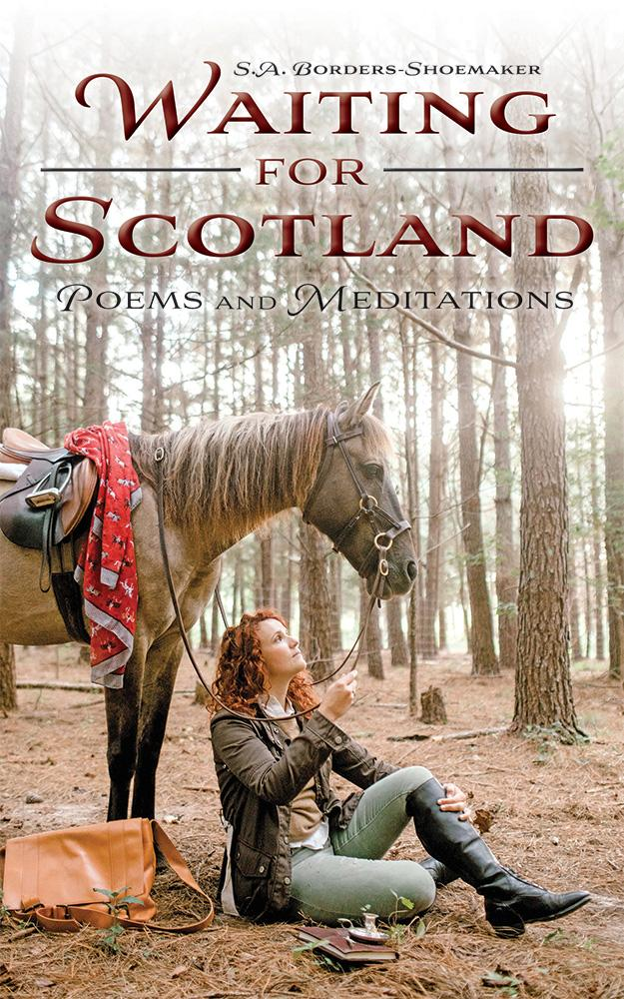](http://www.belleislebooks.com/store/p210/Waiting_for_Scotland.html)

Waiting for Scotland *is a poetry collection about reconciling the past with hopes for the future. Within these pages is the direct confrontation between youthful expectations and sobering realities. Born from the labors of deep soul work, it is all at once a comprehensive story and a series of meditations on identity. This collection acknowledges what has come before and how the past contends with a very real and powerful present. Borders-Shoemaker’s words declare a hope for a different future, rooted in honesty and compassion.*

**About the Author**

[S.A. Borders-Shoemaker](http://www.belleislebooks.com/sabordersshoemaker.html) is an author, poet, and PhD living in Hampton Roads, Virginia. Some influences on her writing include her work in conflict resolution and suicide prevention, as well as her extensive travels abroad. She has over fifteen publications in both national and international outlets, including *Frankenstein & the Phoenix, Rooted in Time, The Conscious Objection*, and numerous op-eds and anthology contributions. *Waiting for Scotland* is her second full-length poetry collection.

Borders-Shoemaker shares her life with her husband Tim and their corgis, Edmund and Lillibette. An avid equestrian, she can often be found riding her mustang, Rosa.

**Interviews available upon request.**

[Belle Isle Books](http://www.belleislebooks.com/), an imprint of [Brandylane Publishers, Inc.](https://brandylanepublishers.com/), is an independent press located in Richmond, Virginia that has published books since 1985.

___________

*Waiting for Scotland: Poems and Meditations* (paperback, 162 pages, $15.95) is available for pre-order from [Amazon](https://www.amazon.com/Waiting-Scotland-Poems-Meditations-Borders-Shoemaker/dp/1958754021), [Barnes & Noble](https://www.barnesandnoble.com/w/waiting-for-scotland-s-a-borders-shoemaker/1142463788?ean=9781958754023), and other fine booksellers.