**FOR IMMEDIATE RELEASE**

**March 2022**

**Publicity Team**

pr@brandylanepublishers.com

804-644-3090

**Confident and Candid, *A Whistleblower’s Requiem* Tells the Story of a Hospital in Peril—and One Man’s Refusal to Look the Other Way**

written by Michael K. Willis

on sale April 1, 2022

“*At least they fear me for my integrity, for always doing what I believe is right*.”

- Michael K. Willis, *A Whistleblower’s Requiem*

[Brandylane Publishers, Inc.](https://www.brandylanepublishers.com/) of Richmond, Virginia, is excited to announce the upcoming release of a new memoir, [*A Whistleblower’s Requiem*](https://www.brandylanepublishers.com/product/awhistleblowersrequiem/), written by Michael K. Willis.

When Michael Willis’ boss, Jim Whitlock, assigns him the task of creating a compliance plan for the publicly owned Bradley Memorial Hospital in Cleveland, Tennessee, Michael resolutely fulfills his duty. He knows that such a compliance plan will help the hospital uncover fraud and abuse in the wake of an initiative by the Department of Justice. But Michael also knows his boss is acting in bad faith: Jim, who originally ran a private, for-profit hospital across town, has been inflating Bradley Memorial Hospital’s revenue through illegal schemes, including fraudulent billing practices.

After delivering the plan, Michael finds it blocked at every turn, as his boss demands his loyalty—or else. But Michael’s sense of justice is too strong to allow him to back down—and when Jim resorts to threatening his job, he’s not about to go quietly.

A searingly honest, fast-paced look into a world of interoffice administration and politics that ultimately transforms into an equally frank courtroom drama, *A Whistleblower’s Requiem* is scheduled for release on April 1, 2022.

[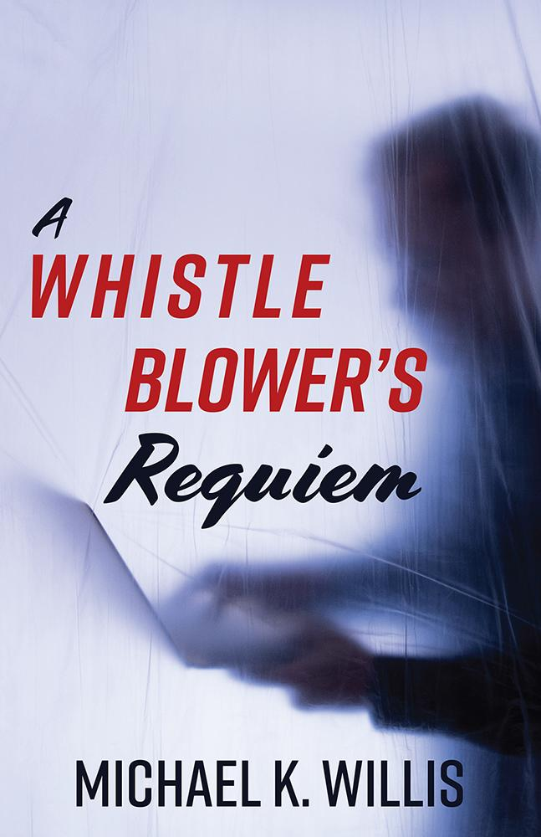](https://www.brandylanepublishers.com/product/awhistleblowersrequiem/)

*Michael K. Willis never imagined he’d become a whistleblower when he accepted a position as the assistant administrator at Bradley Memorial Hospital. This memoir details the real-life events that led him to file a lawsuit against his boss under the Tennessee Whistleblower Act—news that rocked his small southern town in the Appalachian Mountains’ western foothills, as the hospital was a renowned institution. But as hospital administrator Jim Whitlock was placed under indictment, Willis’s ethical standards would not let him look the other way. He would not be blamed, nor made a scapegoat. Instead, he would act to save his job and ensure the truth prevailed.*

**About the Author**

[Michael K. Willis](https://www.brandylanepublishers.com/product/awhistleblowersrequiem/) was born and raised in the Appalachian region of the Blue Ridge Mountains in western North Carolina. He received his bachelor’s degree in political science and history from Western Carolina University and his master’s degree in public administration from the University of Tennessee at Knoxville.

After college, Willis moved to Cleveland, Tennessee, where he spent the next three decades working in county government, most notably as the assistant administrator at Bradley Memorial Hospital. In 2010, he returned to his native home, and currently lives in Asheville, North Carolina.

Willis is also the author of *The Life of Mikey: A Memoir.*

**Interviews available upon request.**

[Brandylane Publishers, Inc.](https://brandylanepublishers.com/) is an independent press located in Richmond, Virginia, that has published books since 1985.

___________

*A Whistleblower’s Requiem* (paperback, 208 pages, $16.95) is available for pre-order from [Amazon](https://www.amazon.com/Whistleblowers-Requiem-Michael-K-Willis/dp/1953021573), [Barnes & Noble](https://www.barnesandnoble.com/w/a-whistleblowers-requiem-michael-k-willis/1140874297?ean=9781953021571), and other fine booksellers. Kindle e-book (retail $4.99) forthcoming.