**FOR IMMEDIATE RELEASE**

**June 2020**

**Christina Kann, Publicist**

[pr@brandylanepublishers.com](mailto:brandylanepr@gmail.com) or 804.644.3090

**The Show Must Go On:**

***Max Brinkley’s Military Brat Mysteries: The Case of the Cursed Curtain Call***

**written by Kim Roedl**

**illustrated by Mindy J.B. Whitten**

**on sale July 8, 2020**

“Max Brinkley is an unwitting super-sleuth all teens and especially military brats will automatically connect with.”

—Kristen Pirog, Army brat and author of *An Army ABC Book* and *A Marine ABC Book*

[Belle Isle Books](http://www.belleislebooks.com/) of Richmond, Virginia, is excited to announce the upcoming release of the new middle-grade fiction book, [*Max Brinkley’s Military Brat Mysteries: The Case of the Cursed Curtain Call*](https://www.amazon.com/Max-Brinkleys-Military-Brat-Mysteries/dp/1951565819/ref=sr_1_1?dchild=1&keywords=the+case+of+the+cursed+curtain+call&qid=1592405557&sr=8-1), written by Kim Roedl and illustrated by Mindy J.B. Whitten. The second installment in this middle school mystery series, *Max Brinkley’s Military Brat Mysteries: The Case of the Cursed Curtain Call* is scheduled for release on July 8, 2020.

[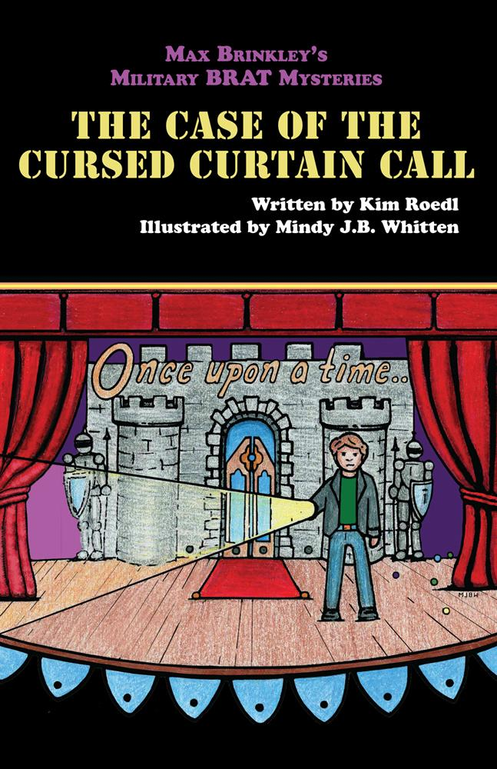](https://www.amazon.com/Max-Brinkley-Case-Ding-Dong-Ditcher/dp/1939930715/ref=sr_1_2?dchild=1&qid=1592411877&refinements=p_27%3AKim+Roedl&s=books&sr=1-2&text=Kim+Roedl)

Seventh-grader Max Brinkley has absolutely no intention of trying out for the middle school play until a chance encounter with eighth-grader Savannah Montgomery changes his mind. One audition later, Max is plunged into a world of cues, crushes, and questions, as a series of mysterious notes warn of a cunning plot to sabotage the play. Soon strange accidents begin to plague the rehearsals, and amid the chaos, Max becomes a suspect. Max could never have imagined that a play would involve this much drama!

**About the Author**

[Kim Roedl](http://www.belleislebooks.com/kim-roedl.html) is a marriage and family therapist who spends her spare time reading novels and writing. A Southerner by birth, she has traveled the world as an Army wife while raising five military BRATs with her husband. Along the way, she also authored the first book in the Max Brinkley series, [*The Case of the Ding-Dong Ditcher*](https://www.amazon.com/Max-Brinkley-Case-Ding-Dong-Ditcher/dp/1939930715/ref=sr_1_2?dchild=1&qid=1592411877&refinements=p_27%3AKim+Roedl&s=books&sr=1-2&text=Kim+Roedl)*.*

**About the Illustrator**

[Mindy J.B. Whitten](http://www.belleislebooks.com/mindy-jb-whitten.html), also a born Southerner, is a graduate of Georgia Tech. She currently has one other release, *An Alpaca in My Pocket,* in addition to the Max Brinkley series. When she is not illustrating, Mindy enjoys her growing family, gardens, and traveling experiences.

**Interviews are available upon request.**

[Belle Isle Books](http://www.belleislebooks.com/) is an imprint of [Brandylane Publishers, Inc](https://brandylanepublishers.com/)., an independent press located in Richmond, Virginia, that has published books since 1985.

____________

*Max Brinkley Military Brat Mysteries: The Case of the Cursed Curtain Call* (middle-grade fiction, 148 pages. Paperback $14.95 / e-book forthcoming) is available for pre-order from[Amazon](https://www.amazon.com/Max-Brinkleys-Military-Brat-Mysteries/dp/1951565819/ref=sr_1_1?dchild=1&keywords=the+case+of+the+cursed+curtain+call&qid=1592405557&sr=8-1), [Barnes & Noble](https://www.barnesandnoble.com/w/max-brinkleys-military-brat-mysteries-kim-roedl/1137096758?ean=9781951565817), and other fine booksellers.