**FOR IMMEDIATE RELEASE**

**February 2020**

**Christina Kann, Publicist**

brandylanepr@gmail.com or 804.644.3090

**A Little Dog on a Big Adventure:**

***Happy Tails***

***Jitterbug Makes a Name for Herself***

**written by Joy Metzer**

**on sale February 20, 2020**

Belle Isle Books of Richmond, Virginia, is proud to announce the upcoming release of [*Happy Tails: Jitterbug Makes a Name for Herself*](https://www.amazon.com/Happy-Tails-Jitterbug-Makes-Herself/dp/1947860992/ref=tmm_pap_swatch_0?_encoding=UTF8&qid=1580318010&sr=8-1) by[Joy Metzer](https://www.joymetzerbooks.com/).The happy tale of Jitterbug, a spunky dachshund who leaves her Arkansas home to become famous in the big city, is scheduled for release on February 20, 2020.

[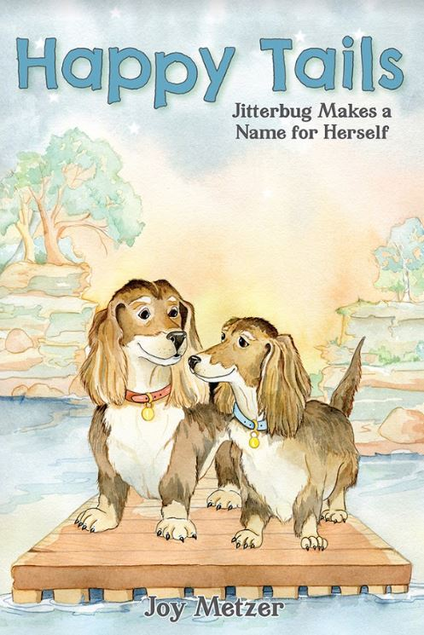](https://www.amazon.com/Happy-Tails-Jitterbug-Makes-Herself/dp/1947860992/ref=tmm_pap_swatch_0?_encoding=UTF8&qid=1580318010&sr=8-1)

Jitterbug lives in a modest cabin in the Ozarks of Arkansas. The runt of a litter of dachshunds, she’s hopelessly at odds with her surroundings and can’t help but dream of making a name for herself in the big city. When opportunity knocks, Jitterbug escapes her pet carrier and lands herself in show business. Her impromptu adventure takes her across the country, acting on stage, on TV, and in commercials. But how fabulous is a life of work, work, work? And how long before she starts to miss home?

**About the Author**

[Joy Metzer](https://www.joymetzerbooks.com/) worked as a professional interior designer for more than twenty-five years, spearheading projects both nationally and abroad, while cultivating an audience for her writing through several book publications and a successful online blog under her former name, Joyce M. Stacks. Though no stranger to real life portrayals intended to enrich the lives of her readers, this is her first effort at writing a children’s chapter book loosely based upon the private life she shares with her husband. She attended both the University of Utah and Texas Christian University and currently resides in Hot Springs, Arkansas, to be near her family, as well as in Lead Hill with her husband, Bill.

**Interviews available upon request.**

____________

[Belle Isle Books](http://www.belleislebooks.com) is an imprint of [Brandylane Publishers, Inc.](http://www.brandylanepublishers.com), an independent press located in Richmond, Virginia that has published books since 1985.

____________

*Happy Tails: Jitterbug Makes a Name for Herself* (paperback, 220 pages, retail $16.95 / Kindle ebook $2.99) is available for pre-order from [Amazon](https://www.amazon.com/Happy-Tails-Jitterbug-Makes-Herself/dp/1947860992/ref=tmm_pap_swatch_0?_encoding=UTF8&qid=1580318010&sr=8-1) and [Barnes & Noble](https://www.barnesandnoble.com/w/happy-tails-joy-metzer/1134949056?ean=9781947860995), and other fine booksellers.