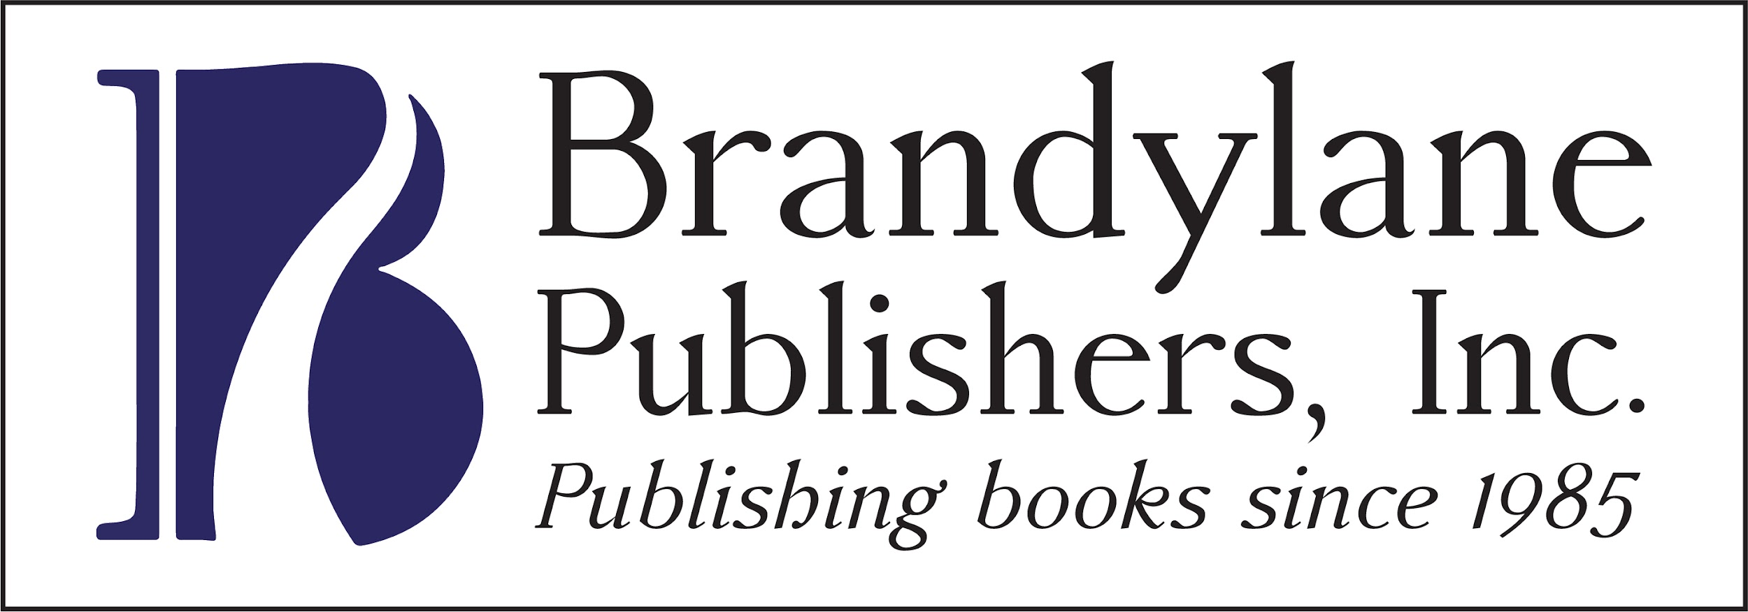

**FOR IMMEDIATE RELEASE**

**August 2020**

**Christina Kann, Publicist**

pr@brandylanepublishers.com

**Take the Wheel: *The Hay-Wagon***

**by Abigail Olson**

**on sale August 20, 2020**

[Belle Isle Books](http://www.belleislebooks.com/) of Richmond, Virginia is proud to announce the upcoming release of the memoir [*The Hay-Wagon*](https://www.amazon.com/Hay-Wagon-Abigail-Olson/dp/1951565304)*,* written by Abigail Olson. Told through a collection of vignettes, *The Hay-Wagon* is a story about respect and a young woman’s journey to find it. *The Hay-Wagon* is scheduled for release on August 20.

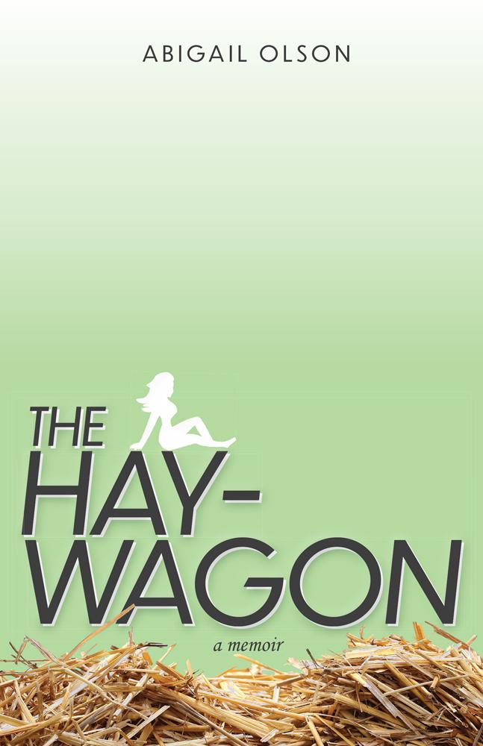

After graduating high school, Abigail achieves her childhood dream of getting her CDL and learning to drive 18-wheelers. That’s where she meets a big roadblock: due to federal age restrictions, she’s too young to drive trucks across state lines. Unsure what to do next, she works as a part-time dump truck driver and part-time receptionist. That is, until she quits her job and relationship on the same day and takes the next flight to Mexico, where she lives for the next four months. Come with Abigail on a journey to self-respect and self-discovery.

**About the Author**

[Abigail Olson](http://www.belleislebooks.com/abigailolson.html) graduated from Maggie L. Walker Governor’s School in 2018. She has her Class A CDL and is working on her private pilot’s license. She lives in Richmond, Virginia.

**Interviews available upon request.**

[Belle Isle Books](http://www.belleislebooks.com/) is an imprint of [Brandylane Publishers, Inc](http://brandylanepublishers.com/)., an independent press located in Richmond, Virginia that has published books since 1985.

____________

*The Hay-Wagon* (184 pages, paperback $14.95 // e-book $4.99) are available for pre-order from [Belle Isle Books](http://www.belleislebooks.com/store/p159/thehaywagon.html), [Amazon](https://www.amazon.com/Hay-Wagon-Abigail-Olson/dp/1951565304), [Barnes & Noble](https://www.barnesandnoble.com/w/the-hay-wagon-abigail-olson/1137239871), and other fine booksellers.