**FOR IMMEDIATE RELEASE**

**March 2024**

**Publicity Team**

804-644-3090  
pr@brandylanepublishers.com

***Lemon and Cedar* Takes Readers on an Incredible Journey as It Teaches Readers about the Plight of the Endangered Red Wolves**

written by Christel Dyer

illustrated by Eric Freeberg

on sale April 2, 2024

“. . . a book for both the very young and the young at heart.”

- Cornelia N. Hutt, chair of the Red Wolf Coalition board of directors

[Belle Isle Books](http://www.belleislebooks.com/) of Richmond, Virginia, is pleased to announce the upcoming release of a new children’s picture book, [*Lemon and Cedar*](http://www.belleislebooks.com/store/p232/Lemon_and_Cedar.html), written by Christel Dyer and illustrated by Eric Freeberg.

In 2014, roughly one hundred red wolves made their home in North Carolina, following the success of a prolonged reintroduction campaign that began in 1987. But ten years later, less than thirty individuals are left in the wild. *Lemon and Cedar* draws attention to the plight of these beautiful animals, and allows child readers to get to know more about this critically endangered species whose range once encompassed the whole of the southeastern US.

Cedar, a red wolf, lives in the Alligator National Wildlife Refuge, a protected area of land on the Albemarle-Pamlico Peninsula in North Carolina. This area is the only safe haven for wild red wolves, which often fall victim to vehicular accidents or are killed by farmers who mistake them for nuisance coyotes.  
 But Cedar yearns to explore the world outside the Refuge—and to find out if there are other red wolves somewhere out there. Accompanied by his friend Lemon, a cottontail rabbit with a daredevil’s penchant for adventure—as her willingness to be friends with a wolf can attest—Cedar sets off on an epic journey to find others like him. Along the way, the pair will encounter other animals both friendly and hostile, and will have to work together to continue their journey safely. But as they travel, one question lingers: if Cedar does find other red wolves, what will happen to the pair’s unusual friendship?

Richly and realistically illustrated with vivid oil paintings that faithfully capture the spirit of all the varied animals within its pages, *Lemon and Cedar* is scheduled for release on April 2, 2024.

[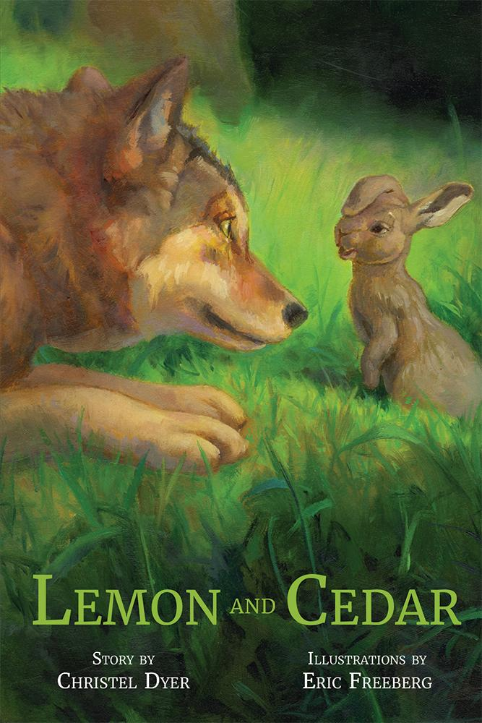](http://www.belleislebooks.com/store/p232/Lemon_and_Cedar.html)

*Cedar the red wolf has always wondered if there are other red wolves like him in the wild. So when a plucky cottontail rabbit named Lemon stumbles into his clearing and takes him up on his offer for an adventure, an unlikely friendship is formed as the pair embark on a journey, leaving their home at the Alligator River National Wildlife Refuge for the first time. Along the way, Lemon and Cedar meet a seabird on the sandy beaches of the Outer Banks, discover large, winged predators while traveling through a swamp, and have a close call with a four-legged foe in a cornfield. Despite the obstacles they face, Cedar and Lemon persist on their quest, searching for red wolves and finding friendship along their way to the Great Dismal Swamp.*

*Conservation of wildlife is important. Ten percent of the author’s proceeds will be donated to the Red Wolf Coalition.*

**About the Author**

[Christel Dyer](http://www.belleislebooks.com/christeldyer.html) developed a passion for books and the environment early, as a child growing up in coastal Virginia. She now lives in Chesapeake, Virginia, where she works in the public sector as a wastewater engineer and scientist and spends her free time advocating for sustainability and the environment.

After learning about red wolves and how few remain in the wild, Christel decided to try her hand at writing a children’s book. She hopes *Lemon and Cedar* will excite children to protect the Earth and the species that populate it.

**About the Illustrator**

[Eric Freeberg](http://www.belleislebooks.com/ericfreeberg.html) has illustrated over twenty-five books for children, including *The Wizard of Oz, Greek Myths,* and *Grimm’s Fairy Tales.* He was the winner of the London Book Fair’s International Children’s Illustration Competition, the Holbein Prize for Fantasy Art, and the Elizabeth Greenshields Foundation Award, and was also the runner-up winner of the SCBWI Magazine Merit Award, as well as the winner of an honorable mention in the SCBWI Don Freeman International Portfolio Competition and the second-place winner in the Clymer Museum’s Annual Illustration Invitational. You can find more information about him on his website, www.ericfreebergillustration.com.

**Interviews available upon request.**

[Belle Isle Books](http://www.belleislebooks.com/), an imprint of [Brandylane Publishers, Inc.](https://brandylanepublishers.com/), is an independent press located in Richmond, Virginia that has published books since 1985.

___________

*Lemon and Cedar* (hardcover, 50 pages, $25.95 / paperback, 50 pages, $14.95) is available for pre-order from [Amazon](https://www.amazon.com/Lemon-Cedar-Christel-Dyer/dp/1958754870), [Barnes & Noble](https://www.barnesandnoble.com/w/book/1144274722?ean=9781958754870), and other fine booksellers.