**FOR IMMEDIATE RELEASE**

**April 2021**

**Christina Kann, Publicist**

[pr@brandylanepublishers.com](mailto:pr@brandylanepublishers.com) or 804.644.3090

***Morning on Solomons***

**written by John “Sonny” Robinson**

**on sale now**

[Belle Isle Books](http://www.belleislebooks.com/) of Richmond, Virginia, is proud to announce the release of *Morning on Solomons* by John “Sonny” Robinson, available now!

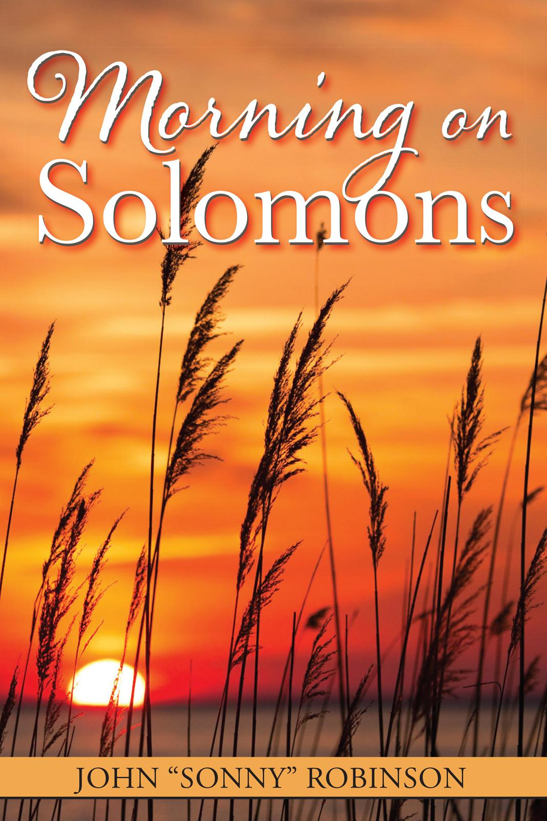

“In this book are gathered short stories relating my recollections of true events from my early years.” So begins Sonny Robinson’s touching and personal collection of tales from his childhood and young adulthood on Solomons Island, a pipe-shaped piece of land located near the mouth of the Patuxent River where it empties into the Chesapeake Bay. Filled with tales of survival and innovation, tragedy and triumph, holiday celebrations and simple vignettes of everyday island life, this collection offers a unique glimpse into a bygone era, while giving hope and encouragement to the next generation to inherit the Bay.

**About the Author**

Sonny Robinson was born on Solomons Island on March 24, 1936, in a small wood frame house close to the ferry dock. He spent his early childhood in Baltimore until the United States became involved with WWII, at which time his family returned to Solomons, where he spent the remainder of his youth. Sonny retired to Florida with his wife, Nancy, in 1995, after forty-two years working for the Newport News shipyard in Virginia. He enjoys boating and fishing.

**Interviews available upon request.**

[Belle Isle Books](http://www.belleislebooks.com/) is an imprint of [Brandylane Publishers, Inc.](https://brandylanepublishers.com/), an independent press located in Richmond, Virginia, that has published books since 1985.

_____

*Morning on Solomons* (72 pages, paperback $11.95 / e-book forthcoming $3.99) is available from [Bookshop](https://bookshop.org/books/morning-on-solomons/9781951565220), [Amazon](https://www.amazon.com/Morning-Solomons-John-Sonny-Robinson/dp/1951565223/ref=sr_1_1?dchild=1&keywords=mornings+on+solomons&qid=1617817389&sr=8-1), [Barnes and Noble](https://www.barnesandnoble.com/w/morning-on-solomons-john-sonny-robinson/1139148458?ean=9781951565220), and other fine booksellers.