**FOR IMMEDIATE RELEASE**

**May 2022**

**Publicity Team**

pr@brandylanepublishers.com

804-644-3090

**Schedule Your Next Jam Session with *My Life According to* Rock Band**

written by Cade Wiberg

on sale May 30, 2022

“The tale of a hopeless romantic who wishes dating came with difficulty settings. I laughed; I cried; I regretted selling my *Rock Band* set a decade ago.”

- R.J. Haynes, writer/producer of *This Is My Year* and *Kidney Beans*

[Belle Isle Books](http://www.belleislebooks.com/) of Richmond, Virginia, is pleased to announce the upcoming release of a new memoir, [*My Life According to Rock Band*](http://www.belleislebooks.com/store/p191/My_Life_According_to_Rock_Band%3A_Or_Fifty-Eight_Short_Stories_About_Life%2C_Love%2C__and_the_Greatest_Video_Game_Ever_Made.html), written by Cade Wiberg.  
 Love hurts.

Friendship is forever.

And music is there through it all.

With a story for each of the fifty-eight songs in the original *Rock Band* video game, this perfectly nostalgic, poignantly honest bookdives headfirst into the brutal and beautiful years that shape us into the people we become—and the music that gets us through them.

A setlist for the moments that shape our adolescences, [*My Life According to Rock Band*](http://www.belleislebooks.com/store/p191/My_Life_According_to_Rock_Band%3A_Or_Fifty-Eight_Short_Stories_About_Life%2C_Love%2C__and_the_Greatest_Video_Game_Ever_Made.html)is scheduled for release on May 30, 2022.

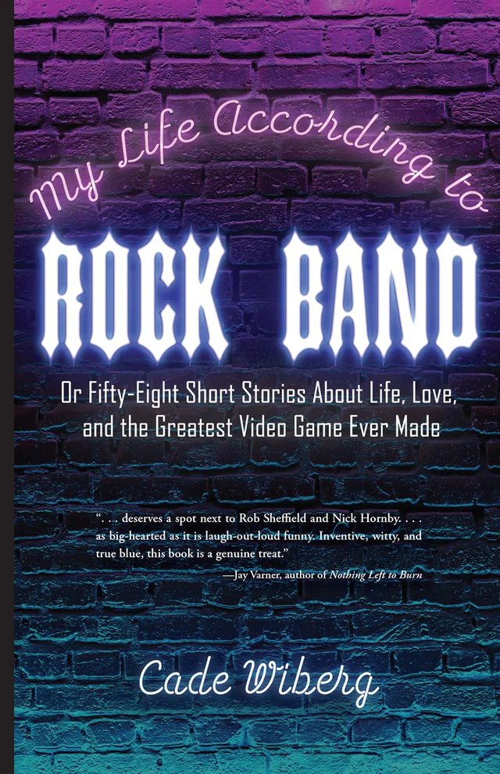

*When fifteen-year-old Cade first laid eyes on the box that held the video game Rock Band under his family Christmas tree, he could see his whole future: the face-melting guitar solos he’d play to stadiums of screaming fans, the fame and glory that would follow him like an entourage, the girls that would beg for a night with Cade the Rock God . . .*

*But that’s not exactly how it went.*

*Instead of a packed stadium, it was a packed college apartment, and girls didn’t exactly beg him, although he did find himself in the highs and lows of love a few times. He didn’t get to play to thousands of screaming fans either, but the few real friends he found along the way, well . . . that part turned out to be just as epic.*

“Cade Wiberg’s debut deserves a spot next to Rob Sheffield and Nick Hornby. It’s not often you come across a memoir that’s as big-hearted as it is laugh-out-loud funny. A life-affirming coming-of-age story that celebrates a generation’s shared love of music and popular culture, this book is a genuine treat.”

- Jay Varner, lecturer in writing, rhetoric, and technical communication at James Madison University and author of *Nothing Left to Burn*

**About the Author**

[Cade Wiberg](http://www.belleislebooks.com/cadewiberg.html) was born and raised in northern Virginia, and has written creative nonfiction for over a decade. He is a JMU graduate with a passion for film, music, and television. In his spare time, Cade enjoys playing guitar, songwriting, and hosting *Rock Band*/karaoke nights at local breweries in his hometown of Charlottesville, VA.

**Interviews available upon request.**

[Belle Isle Books](http://www.belleislebooks.com/), an imprint of [Brandylane Publishers, Inc.](https://brandylanepublishers.com/), is an independent press located in Richmond, Virginia that has published books since 1985.

___________

*My Life According to Rock Band* (paperback, 356 pages, $20.95) is available for pre-order from [Amazon](https://www.amazon.com/Life-According-Rock-Band-Fifty-Eight/dp/1953021697), [Barnes & Noble](https://www.barnesandnoble.com/w/my-life-according-to-rock-band-cade-wiberg/1140995420?ean=9781953021694), and other fine booksellers. Kindle e-book (retail $4.99) forthcoming.