**FOR IMMEDIATE RELEASE**

**August 2022**

**Publicity Team**

pr@brandylanepublishers.com

804-644-3090

**Question Tradition and Discover Your Story with A New *Noble* Fantasy for Middle Grade Readers**

written by Stephanie Parwulski

on sale September 9, 2022

“Precious and refreshing—a timeless parable about the power of choice and the healing rewards of kindness. Beautifully written and aptly named.”

- E. S. Christison, award-winning author of *The Blameless*

[Belle Isle Books](http://www.belleislebooks.com/) of Richmond, Virginia, is pleased to announce the upcoming release of a new work of fantasy for middle-grade readers, [*Noble*](http://www.belleislebooks.com/store/p197/Noble.html), written by Stephanie Parwulski.

Enter a kingdom where threads tell tales, men tell lies, and old wrongs fester amid apathy. Against this backdrop of tyranny and tradition, a young boy seeks to learn to weave the threads of stories—while others seek a princess who has escaped the palace walls. In this loving homage to classic folk tales,readers will learn that fear and misunderstanding can be our harshest masters, but a loving family always finds its own—and things aren’t always what they seem.

It takes more than a title to be noble.

A tale of conventions both honored and broken, reminiscent of Lois Lowry’s *The Giver*, *Noble* is scheduled for release on September 9, 2022.

[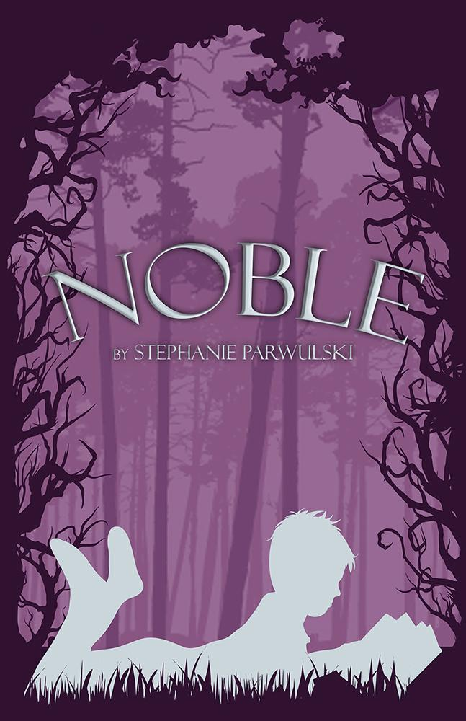](http://www.belleislebooks.com/store/p197/Noble.html)

*Every town in the kingdom of Ansel has a storyteller, a man who weaves threads of magic into stories to share with the men of the community—and only the men, for in Ansel, women are forbidden from learning to read.*

*Elbon doesn’t know why Storyteller chose him as an apprentice. After all, he has no family, no friends, and not much talent for hearing the words woven into the colorful threads strung on Storyteller’s magic harp. Still, Elbon does his best to make his teacher proud . . . even if he doesn’t feel confident that he can.*

*But when Elbon meets a frightened boy named Freddie who claims to be running away from home—and when agents from the royal palace arrive not long after in search of a missing princess—Elbon and his new friend must work together to uncover the secrets that have shaped both their lives . . . and maybe right a few ancient wrongs along the way.*

**About the Author**

[Stephanie Parwulski](http://www.belleislebooks.com/stephanieparwulski.html) is a children’s book author and mental health advocate whose two picture books, *Beatrice and the Sunflower Gift* and *Gloria's Hope Tree*, champion messages of kindness, the healing power of love, and the importance of bringing our invisible stories to light. Stephanie is living her dream in creating stories for children and “kids at heart” to enjoy. In addition to her love of writing, she has a passion for reading, singing, enjoying nature, and helping others.

Stephanie cherishes spending quality time with her family and friends and going on adventures in her beloved hometown of Buffalo, NY, where she currently resides. She is also a preschool teacher, and her work with children brings her immense joy. She looks forward to writing more stories from the heart and sharing them with her readers.

**Interviews available upon request.**

[Belle Isle Books](http://www.belleislebooks.com/), an imprint of [Brandylane Publishers, Inc.](https://brandylanepublishers.com/), is an independent press located in Richmond, Virginia that has published books since 1985.

___________

*Noble* (paperback, 112 pages, $14.95 / Kindle e-book, $3.99) is available for pre-order from [Amazon](https://www.amazon.com/Noble-Stephanie-Parwulski/dp/1953021751), [Barnes & Noble](https://www.barnesandnoble.com/w/noble-stephanie-parwulski/1141467557?ean=9781953021755), and other fine booksellers.