**FOR IMMEDIATE RELEASE**

**October 2022**

**Publicity Team**

804-644-3090  
pr@brandylanepublishers.com

**Take a Trip Through the US Capital and Uncover *The Secret of the Legendary Tribe*!**

written by John Roche

on sale November 22, 2022

“...Some people have a knack for finding real adventure. The Mahood and Gonzales kids fall into that category, and they would never forget their adventure that began in the Mahoods’ backyard on a muggy July afternoon in Alexandria, Virginia.”

- from *The Secret of the Legendary Tribe*

[Belle Isle Books](http://www.belleislebooks.com/) of Richmond, Virginia, is pleased to announce the upcoming release of a new middle-grade novel, [*The Secret of the Legendary Tribe*](http://www.belleislebooks.com/store/p202/The_Secret_of_the_Legendary_Tribe.html) by John Roche.

Preteens Hector, Marci, Kay, and Archie are more than just best friends—they’re also neighbors, sibling pairs, and the most adventurous group of middle schoolers this side of the Potomac River. Not even grounding, broken bones, or their various disabilities can deter them—until one day, an accident during one of their adventures leaves Hector hospitalized and in a coma. Now Hector’ssister Marci and her friends—including her dog, Smokey—must find the Spearhead, a curative artifact of cultural significance to Kay and Archie’s Native American tribe, the Patawomecks. Their quest will take them on a journeyacross Washington, DC,to a variety of real-world locations steeped in American history and described in rich detail. On the way, they’ll have to rely on their wits and each others’ strengths as they encounter unexpected helpers, shadowy criminals, a menacing politician, and even a troupe of ghosts—and more magic than they ever thought possible.

A breakneck adventure in the spirit of *National Treasure* and the beloved children’s classic *From the Mixed-Up Files of Mrs. Basil E. Frankweiler,* *The Secret of the Legendary Tribe* is scheduled for release on November 22, 2022.

[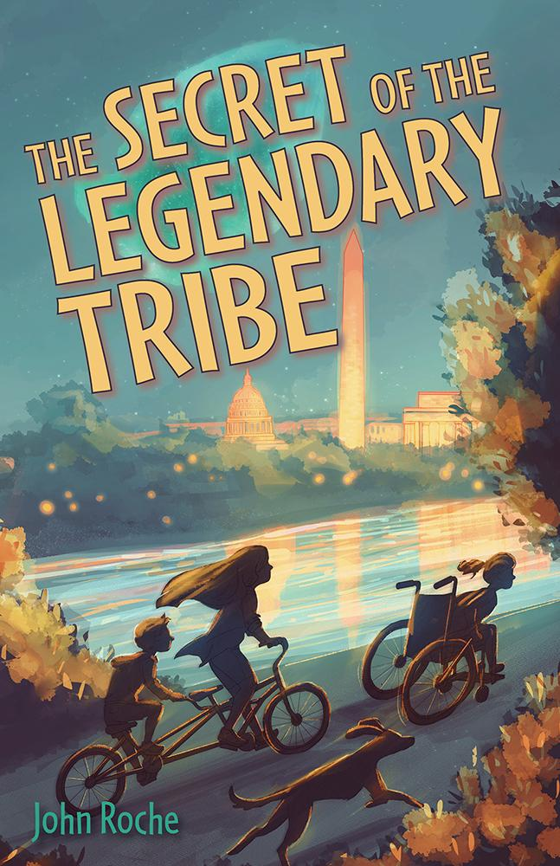](http://www.belleislebooks.com/store/p202/The_Secret_of_the_Legendary_Tribe.html)

*When Marci’s brother, Hector, gets hurt in a car accident, it seems the doctors won’t be able to help him. Marci and her friends take matters into their own hands and search for a magical artifact, the ancient Spearhead, which is rumored to have healing powers. Unfortunately, the spearhead’s whereabouts have been lost to time—but these kids won’t let anything stop them! Join Marci, Kay, and Archie at landmarks around the nation’s capital as they hunt for clues and dodge their sinister competitors who have nefarious plans for the Spearhead. It might be the only thing that can save Hector.*

**About the Author**

[John Roche](http://www.belleislebooks.com/johnroche.html) is a native of Alexandria, Virginia, where he lives with his wife and four daughters. When he’s not driving his daughters to soccer and softball games or writing adventure stories for children, he works as a lawyer in Northern Virginia and Washington, DC.

**Interviews available upon request.**

[Belle Isle Books](http://www.belleislebooks.com/), an imprint of [Brandylane Publishers, Inc.](https://brandylanepublishers.com/), is an independent press located in Richmond, Virginia that has published books since 1985.

___________

*The Secret of the Legendary Tribe* (paperback, 184 pages, $16.95 / Kindle e-book, $3.99) is available for pre-order from [Amazon](https://www.amazon.com/Secret-Legendary-Tribe-John-Roche/dp/1953021794), [Barnes & Noble](https://www.barnesandnoble.com/w/the-secret-of-the-legendary-tribe-john-roche/1141883582?ean=9781953021793), and other fine booksellers.