FOR IMMEDIATE RELEASE
March 2020
Christina Kann, Publicist
brandylanepr@gmail.com or 804.644.3090

A Strange and Beautiful Life : Wacky on the Junk
written by Kathy Varner
on sale March 31, 2020

“Kathy Varner shows just how positively one can turn a seemingly hopeless life around and become a more complete person, by pure depth of character or simply growing up and seeing the error of one’s ways.”
—Matt McAvoy, author of Granjy’s Eyes, Kill the Witch!, Clouds, and The Black Line

Belle Isle Books is excited to announce the upcoming release of a new memoir, Wacky on the Junk, written by Kathy Varner. Looking back on her misspent youth of drinking, drugs, and processed sugar, Kathy reflects on all the wacky adventures encountered on the road to health and happiness in Wacky on the Junk, scheduled for release on March 31, 2020.

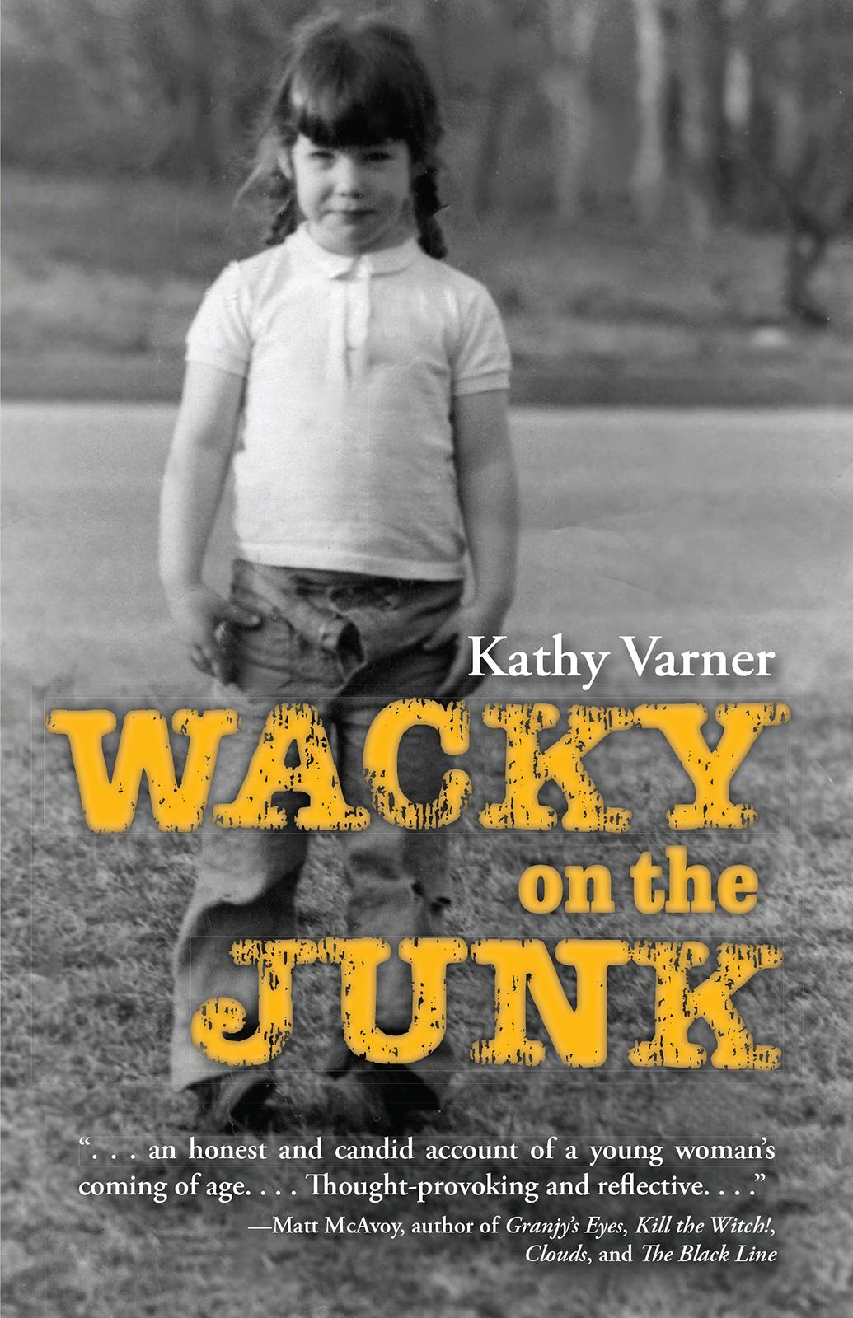

In this hilarious debut memoir, Kathy Varner reflects on a life lived on the fringes of ordinary. From an awkward childhood as the youngest of five, living off sweets and processed foods, to a wild adolescence of drinking, drugs, and Deadhead hijinks, to a harrowing career with social services, Kathy takes it all in stride, embracing the beauty and pain of life with a sardonic wit and a sense of adventure that remains undampened—no matter how wacky things get!

About the Author
Kathy Varner lives in Richmond, Virginia. She’s a paralegal by trade, but a writer by passion. When she’s not working or writing, you may find her gardening, cooking, hiking with her Shelties, dancing to her husband’s bands, reading, and laughing. She hopes that you will one day find her riding her bike through the Outer Hebrides in Scotland.

For more information about the author, please visit her website.

Interviews are available upon request.

Belle Isle Books is an imprint of Brandylane Publishers, Inc., an independent press located in Richmond, Virginia that has published books since 1985.
___________

Wacky on the Junk (paperback, 136 pages, retail $14.95) is available for pre-order from Amazon, Barnes and Noble, and other fine booksellers. Kindle ebook (retail $2.99) forthcoming.

