**FOR IMMEDIATE RELEASE**

**May 2021**

**Christina Kann, Publicist**

[pr@brandylanepublishers.com](mailto:pr@brandylanepublishers.com)

804.644.3090

**A Fantastical Journey through Time and Across the Atlantic:**

***Witching Moon***

**written by K.E. Bonner**

**on sale June 1, 2021**

“K.E. Bonner’s *Witching Moon* renders the historical American South into a rich and magical land in which ancient immortals of myth confront a real and messy history. From the first engrossing paragraph, the reader is catapulted on a riveting adventure of the familiar and the fantastic with engrossing beings that have much to teach and much to learn.”

—Stacey Margaret Jones, author of *Mr. Catherine*

[Belle Isle Books](http://www.belleislebooks.com/) of Richmond, Virginia, is proud to announce the upcoming release of [*Witching Moon*](https://bookshop.org/books/witching-moon-9781947860926/9781947860926),written by [K.E. Bonner](http://www.kebonner.com). Set out on a grand destiny of self discovery and a bit of magical adventure. *Witching Moon* is scheduled for release on June 1, 2021.

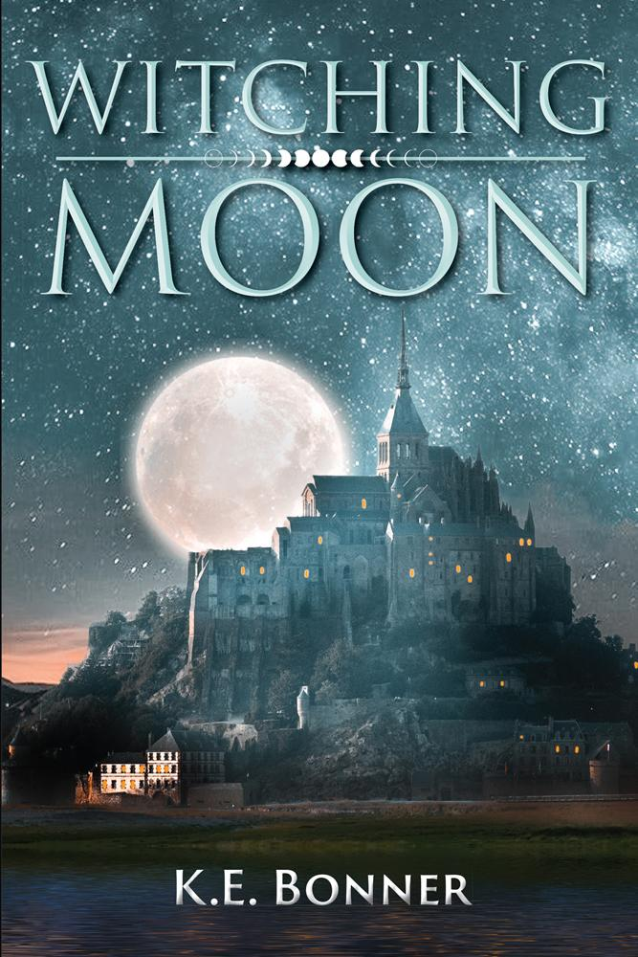

Every once in an eon, when the Earth eclipses the moon on a winter solstice, an immortal is born under a witching moon. Anne has always had the strangest feelings--memories she couldn’t place; strangers she inexplicably yearned for. After she rescues the enigmatic Phillip from a shipwreck, her comfortable life on the island of Cusabo is shattered, and the mystery of her destiny starts to fall into place. Anne leaves behind the life she’s always known and sets out with Phillip on an arduous journey to Amaranth, where her ancient family awaits her. But the path is dark and daunting, and Anne’s powers have only just begun to manifest.

**About the Author**

[K.E. Bonner](http://www.kebonner.com) was always the first kid to sit down during a spelling bee. It wasn’t until she was an adult that she was diagnosed with dyslexia, which explained why she always had to study three times harder than her peers. Being dyslexic taught her perseverance and kindness, her two favorite attributes. She lives in Georgia with her husband, two sons, and two dogs. When not writing, she loves to read, swim, explore new places, and meet fascinating people. If you have a dog, she would love to scratch behind its ears and tell it what a good pup it is.

**Interviews available upon request.**

[Belle Isle Books](http://www.belleislebooks.com/) is an imprint of [Brandylane Publishers, Inc.](https://brandylanepublishers.com/), an independent press located in Richmond, Virginia, that has published books since 1985.

_____

*Witching Moon* (298 pages, paperback $18.95 / e-book $3.99) is available for pre-order from [Bookshop.org](https://bookshop.org/books/witching-moon-9781947860926/9781947860926), [Amazon](https://www.amazon.com/gp/product/1947860925?pf_rd_r=BZZAPR4827NJ8G1E8RZF&pf_rd_p=5ae2c7f8-e0c6-4f35-9071-dc3240e894a8&pd_rd_r=95f67863-4651-4d3a-87c8-07df3d6a89d3&pd_rd_w=AaJNS&pd_rd_wg=jwMfO&ref_=pd_gw_unk), [Barnes and Noble](https://www.barnesandnoble.com/w/witching-moon-ke-bonner/1138844843?ean=9781947860926), and other fine booksellers.