**FOR IMMEDIATE RELEASE**

**September 2022**

**Publicity Team**

pr@brandylanepublishers.com

804-644-3090

***You’re Not from Around Here, Are You?: Notes from a Naturalized Southerner* Shares a Northerner’s Experience of Falling in Love with the South**

written by Martin Lehfeldt

on sale October 20, 2022

“. . . a love affair with a place and its people. . . . witty, wise, and a sheer delight to read.”

- Thomas G. Long, professor emeritus, Emory University

[Belle Isle Books](http://www.belleislebooks.com/) of Richmond, Virginia, is pleased to announce the upcoming release of a new memoir, [*You’re Not from Around Here, Are You?: Notes from a Naturalized Southerner*](http://www.belleislebooks.com/store/p204/You%E2%80%99re_Not_From_Around_Here%2C_Are_You%3F%3A_Notes_from_a_Naturalized_Southerner.html), written by Martin Lehfeldt.

Born in New York, Martin Lehfeldt didn’t expect to head south for work. But life sometimes has a funny way of heading where you least expect it, and Martin found himself traveling all over the South, visiting historically Black colleges in an effort to find placements for young teachers. In the days before GPS and even (sometimes) reliable maps, he sought them out the hard way, seeking out predominantly Black neighborhoods, asking advice from locals, and on one memorable occasion, even getting stuck in the mud on a little-used dirt road.His sojourns took him to Baton Rouge, to the Florida Keys, and to various colleges in the Atlanta University Center Consortium, a group of historically Black colleges and universities in Atlanta, Georgia. Over a lifetime of education, social activism, and support of Black leaders, this adopted son of the South has spent fifty years in the region—not long enough to temper his fascination with its down-home cooking, unique idioms, and warm winters; but long enough to call the South a home.

A witty celebration of African American history, family, and all life’s funny ways, *You’re Not from Around Here, Are You?: Notes from a Naturalized Southerner* is scheduled for release on October 20, 2022.

[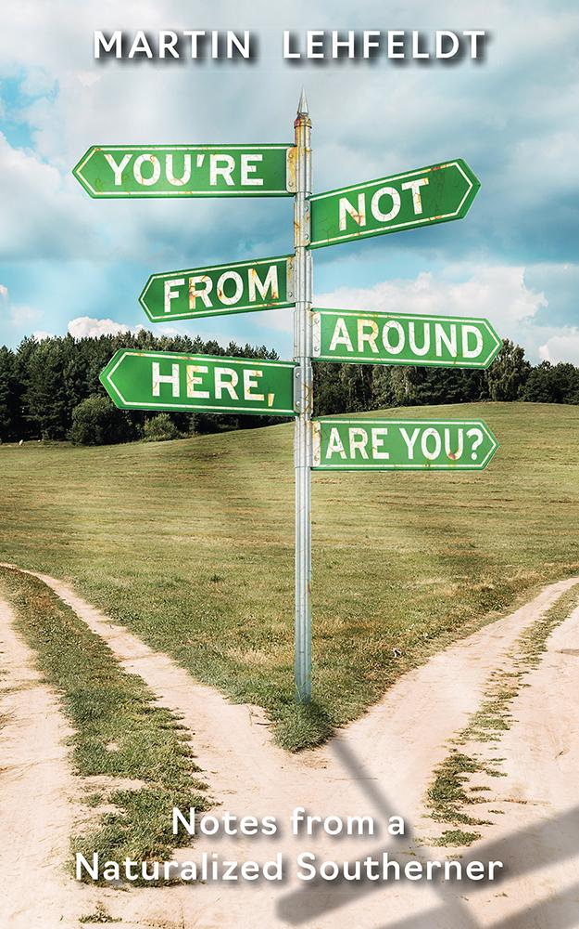](http://www.belleislebooks.com/store/p204/You%E2%80%99re_Not_From_Around_Here%2C_Are_You%3F%3A_Notes_from_a_Naturalized_Southerner.html)

*More than five decades ago, Northeast native Martin Lehfeldt was so captivated by the South that he made it his home. Reflecting on his experiences in the aptly titled* You’re Not from Around Here, Are You?*, Lehfeldt has assembled a uniquely diverse collection of impressions that embrace an overview of the region’s historically black colleges and universities, the unequaled pleasure of sipping a Bloody Mary on a rainy Saturday morning in New Orleans, the joys of 1960s-era first-class air travel, the discovery of a coon dog cemetery, a revelatory visit to Key West, throwing a good party, brushes with celebrity, and plenty more. Open Lehfeldt’s witty collection of sketches at virtually any page and find a story that lyrically captures a moment, a feeling, and possibly a piece of your heart.*

**About the Author**

[Martin Lehfeldt](http://www.belleislebooks.com/martinlehfeldt.html) was born in New York City, raised in Camden, New Jersey, and attended Quaker institutions from Moorestown Friends School through Haverford College. Strongly encouraged to follow his grandfather and father into the Lutheran ministry despite a desire to become a journalist, he earned a Master of Divinity at Union Theological Seminary in New York—but then “self-defrocked” in the mid-1960s. The opportunity to direct a program that recruited and placed outstanding young faculty members at historically Black colleges throughout the South gave him a unique perspective on that region, and lured him to Atlanta. What was intended to be a brief sojourn blossomed into a career as a college development officer, a fund-raising consultant, and President of the Southeastern Council of Foundations. During five decades as a “naturalized” Southerner traveling widely in the region, he has become known as a speaker and author whose books include *The Sacred Call, Notes from a Non-Profitable Life*, and (with Jamil Zainaldin) *The Liberating Promise of Philanthropy.*

**Interviews available upon request.**

[Belle Isle Books](http://www.belleislebooks.com/), an imprint of [Brandylane Publishers, Inc.](https://brandylanepublishers.com/), is an independent press located in Richmond, Virginia that has published books since 1985.

___________

*You’re Not from Around Here, Are You?: Notes from a Naturalized Southerner* (paperback, 178 pages, $16.95) is available for pre-order from [Amazon](https://www.amazon.com/Youre-Not-Around-Here-Are/dp/1953021964), [Barnes & Noble](https://www.barnesandnoble.com/w/youre-not-from-around-here-are-you-martin-lehfeldt/1141988803?ean=9781953021960), and other fine booksellers.